**Framework**

**1. Hibernate**

**2. SpringCore**

**3. Spring MVC**

**4. SpringBoot**

**5. WebService**

**6. Spring Security**

**7 .Swagerr**

**8. Microservice**

**9.Runtime class**

**10.Optional classs,Respose Entity class**

**11.File upload,java mail Api,Global Exception handling,Validation**

**12.lock and unlock and forget password,reset**

**Hibernate:-**

* project ko maintain krne ke liye hota hain ,Jo kaam jdbc se krte hain wo kaam hibernate se krte hain
* hibernate ki littreal meaning hoti hain stage ko manage krna hota hain
* jo data maine database main dala aur use main 20 saal baad dekhu to wahi data rahe usi ko hibernate kahate hain
* java ke andar orm(object relational mapping) design pattern hota hain usko implement krne ke liye hibernate ka use kiya jata hain iska main perpose hota hain
* hibernate object ki persestensi ko manage krta hain
* persestance ka matlab hota hain object ki state ko manage krna
* object ko relational database main map krana
* **jdbc se hum jab connections krte hain to usme problem ye thi jaise maine hazar connection kiya aur maine mysql database use kiya aur kl ko client ne kaha ki ab apko oracle use krna hain to aap ko phir se likhana hoga kyuki dono ka syntax alag hota hain isliye hibernate use kiya jata hain**
* **ye jo database use kroge wo us hisab se query dega aur internally jdbc hi use krta hain but jdbc main java ka connection direct hota hain aur specific query hoti hain kl ko agar apko change krna hain database to her jagah change marna pad Sakata hain**
* but agar aap hibernate use kroge to java ka program hibernate ko use krega aur hibernate jdbc ko use krega aur phir database ye indirect approach hain but loosely coupled hain kyuki aise hone per hibernate ko pahle hi pata ho jata hain konsa database hain wo usi hisab se query dega
* 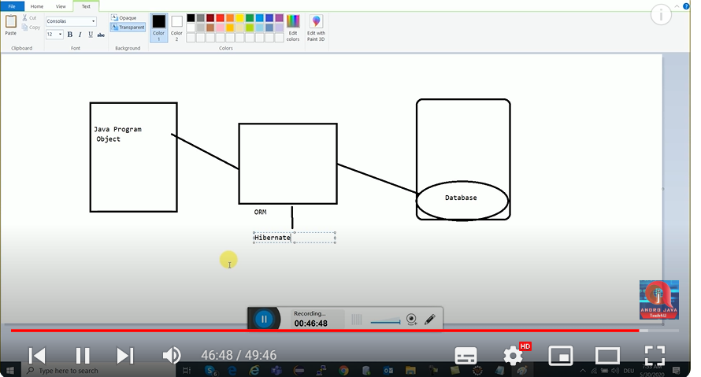

Components of Hibernate:-

* Session
* Session Factory
* **Configuration**
* Query
* **Configuration files**

**Need**

**Jar mysql& hibernate**

* <property name=*"hibernate.connection.driver_class"*>com.mysql.cj.jdbc.Driver</property>//ye dirver hota hain iske sath connection krne ke liye
* <property name=*"hibernate.connection.url"*>jdbc:mysql://localhost:3306/mycart</property>
* <property name=*"hibernate.connection.username"*>root</property>
* <property name=*"hibernate.connection.password"*>1234</property>
* <property name=*"hibernate.dialect"*>org.hibernate.dialect.MySQL8Dialect</property>
* //jitane bhi dialect hote hain unki kuch na kuch meaning hoti hain
* Her ek database ka alag -2 dilect hota hain like MySql8 ka alag hota hain 6 ka alag aur oracle ka alag hota hain yahi se jana pata hain cfg file ki hume kis database ke liye kaam krna hain
* <property name=*"hibernate.hbm2ddl.auto"*>update</property>
* Ye automatic update kr deta hain
* <property name=*"hibernate.show_sql"*>true</property>
* //sql ko show krna chate hain to show sql use kro

**Step of Connection Provider with Hibernate.cfg.xml:**

* Configuration configuration=**new** Configuration(); sabse pahle configuration class ko load krna hota hain
* Configuration ka method hota hain configure main hibernate cfg file ko pass krna hota hain
* Aur jab configuration k eke object per buildSessionFactory() method chalate hain to build session factory ka object mil jata hain
* SessionFactory ka method hota hain open session jo return krke deta hain session ka object we can say that connection ho jata hain
* Use ke baad session per method chalate hain beginTransection()
* And aur phir save krte hain aur beginTransection return krke deta hain object transection ka aur us per hum commit kr dete hain

**Hibernate Architecure:**

In this architecture include some class and interface -

**Configuration:**

* Configuration is a class which is present in org.hibernate.cfg package. It activates Hibernate framework. It reads both configuration file and mapping files.

It activate Hibernate Framework

**Configuration cfg=new Configuration();**

It read both cfg file and mapping files

**cfg.configure();**

* It checks whether the config file is syntactically correct or not.
* If the config file is not valid then it will throw an exception. If it is valid then it creates a meta-data in memory and returns the meta-data to object to represent the config file.

**SessionFactory:**

* SessionFactory is an Interface which is present in org.hibernate package and it is used to create Session Object.
* It is immutable and thread-safe in nature.

buildSessionFactory() method gathers the meta-data which is in the cfg Object.

From cfg object it takes the JDBC information and create a JDBC Connection.

**SessionFactory factory=cfg.buildSessionFactory();**

**Session:**

* Session is an interface which is present in org.hibernate package. Session object is created based upon SessionFactory object i.e. factory.
* It opens the Connection/Session with Database software through Hibernate Framework.
* It is a light-weight object and it is not thread-safe.
* Session object is used to perform CRUD operations.

**Session session=factory.buildSession();**

**Transaction:**

* Transaction object is used whenever we perform any operation and based upon that operation there is some change in database.
* Transaction object is used to give the instruction to the database to make the changes that happen because of operation as a permanent by using commit() method.

**Transaction tx=session.beginTransaction();**

**tx.commit();**

**Query:**

* Query is an interface that present inside org.hibernate package.
* A Query instance is obtained by calling Session.createQuery().
* This interface exposes some extra functionality beyond that provided by Session.iterate() and Session.find():
  1. A particular page of the result set may be selected by calling setMaxResults(), setFirstResult().
  2. Named query parameters may be used.

ORM Tool:

* Pahle problem ye this sql query jo thi wo database -2 vary hoti rahati thi us problem ko solve krne ke liye orm picture main aya tha agar poore query main change krna hain for example aaj app mysql database se connect hain aur us query ko likhana but database change krna hain to aapko query ko phir likhan padata tha isliye ye picture main ayi
* **Orm ek design pattern hota hain , Orm kahata hain muje object de do main database se connect kr dunga ,but isko connect krne ke liye orm tool use krega like ,hibernate ,toplink,ecpliselink**
* Hibernate ,tooplink,ecpliselink jitane bhi tool hain wo orm ko implemetion ko follow krte hain aur apne tarike se orm ko implement krte hian
* Jitane bhi tool unki apni api hogi apne tarike honge yaha per problem ye ayi jasie for example hibernate ki api ko toplink nahi use kr sakta hain aur toplink ko api ko hibernate nahi use kr sakta hain to isi problem ko solve krne ke liye JPA(Java persistence Api picture main ayi agar aap is api
* Jaise aapne hiberanate framework use krke koi project banaya to kl ko aap dusra framwork use krna chahate ho to dusra framework nahi use kr payega to kahi nak ahi dependency a rahi thi
* **Usi dependency ko door krne ke liye JPA picture main aya**
* **Isi probolem ko solve krne ke liye sunmicrosystem ne JPA spicfication banaye**
* **\*\*\*\*Suncmicrosystem ne ORM ko implement krne ke liye JPA banaya**
* **Aur ab agar hum hibernate ko use krke JPA ke specification ko follow ko jo standered set kiya tha microsystem ne use follow krenge to main usi same project dusre framework se per bhi use kr sakate hain for example aaj main hibernate framework use kiya to main same project ke liye main toplink follow kr Sakata hu but agar hibernate JPA ke standerd ko follow krta hain to**
* **Without JPA use ORM You can’not migrate one framework to another framework**
* **With JPA use ORM You can migrate one framework to another framework**

An ORM tool simplifies the data creation, data manipulation and data access. It is a programming technique that maps the object to the data stored in the database.

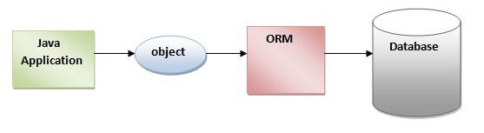

**ORM** is a technique for converting data between Java objects and relational databases (table). In simple words, we can say that the **ORM implements responsibility of mapping the object to relational model and vice-versa**. the ORM tool does mapping in such a way that model class becomes a table in the database and each instance becomes a row of the table.

**Advantages of ORM Tool**

ADVERTISEMENT

ADVERTISEMENT

* It saves time and efforts.
* It gives pace to development process.
* It reduces the development cost.
* It provides connectivity to the database.
* It makes development more object-oriented.
* Easy transaction management.
* No need to implement database manually.
* Modification in any model (object or relational model) does not affect each other.

ORM Tools

There are many ORM tools available but the following ORM tools are the most commonly used.

* [Hibernate](https://www.javatpoint.com/hibernate-tutorial)
* TopLink
* EclipseLink
* OpenJPA
* MyBatis (formally known as iBatis)

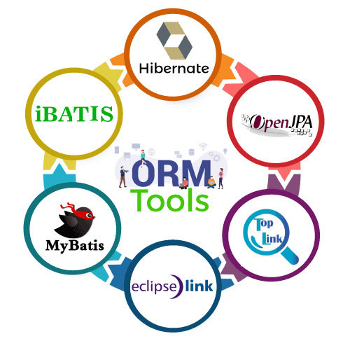

**Hibernate ka application banana hain to 5 cheeze pata hona chaiye**

**First of all create maven project**

**Second add hibernate dependency and database dependency**

**Create cfg file add Cfg file add driver class, url,name,password, dialect,auto,**

**After that create connection provider class and conection between check cfg file and connection provider class after that create dto class and create hbm file**

**Hbm file mapping add in cfg class after that create main class then check data store database or not**

* Hibernate -Jar file-or dependency and mysql-dependency or jar for maven
* Agar aap database se deel krna chahhate ho to aap ek configuration file bana hota hain uske liye resources folder banate hain aur cfg file ek application ki ek hoti hain aur isme hum apne database ki detail rakhate hain
* Like driver ,url,username,password,dealect, aur hbm ki entry krna hot hain
* Aur hibernate file ek xml file hoti hain aur her xml file ka ek schema hoti hain
* First line xml ka version hain
* Aur dusri line xml ka schema hain
* Schema ek name space hoti hain jaha per xml main jitane bhi tag hote hain unki meaning schema main define hoit hain
* Agar hum schema hata denge to jitane bhi tag hain wo kaam krna band kr denge
* <hibernate configuration> ye hibernate configuration ka tag hota hain . this is root tag -jo ye batata hain ye hibernate ki configuration file hain
* Aur hibernate tag eke andar session factory tag hota hain
* Aur session factory andar further tag hota hain property tag hota hain
* Hibernate ke andar jo property tag hota hain ye samjho ek datamember ki tarah hota
* **Ye hibernate ke andar bani banayi property hoti hain jisme aap value de deta ho for example name main jo likha hain wo inbuilt hain aur jo tag ke beech main likha hain wo maine value de hain**
* **Dialect hi batata hain tumhe konse se database se interact krna hain aur kis se connectivity krni hain aur kis database ke liye query generate krni hain**
* **We can say that dialect wo technique hoti hain jo database database query generate kr pata hain**
* **Aur her database ke liye dialect alag-2 hota hain oracle ke liye alag hoga aur Mysql8 ke liye alag hoga aur Mysql5 ke liye alag hoga etc**

**<property name=*"hibernate.hbm2ddl.auto"*>create</property>:-**

hibernate.hbm2ddl.auto Automatically validates or exports schema DDL to the database when the SessionFactory is created. With create-drop, the database schema will be dropped when the SessionFactory is closed explicitly.

e.g. validate | update | create | create-drop

So the list of possible options are,

* **validate: validate the schema, makes no changes to the database.**
* **create-only: database creation will be generated.**
* **drop: database dropping will be generated.**
* **update: update the schema.**
* **create: creates the schema, destroying previous data.**
* **create-drop: drop the schema when the SessionFactory is closed explicitly, typically when the application is stopped.**
* none: does nothing with the schema, makes no changes to the database

These options seem intended to be developers tools and not to facilitate any production level databases, you may want to have a look at the following question; [Hibernate: hbm2ddl.auto=update in production?](https://stackoverflow.com/questions/221379/hibernate-hbm2ddl-autoupdate-in-production)

<property name=*"hibernate.connection.driver_class"*>com.mysql.cj.jdbc.Driver</property>

<property name=*"hibernate.connection.url"*>jdbc:mysql://localhost:3306/mycart</property>

<property name=*"hibernate.connection.username"*>root</property>

<property name=*"hibernate.connection.password"*>1234</property>

<property name=*"hibernate.dialect"*>org.hibernate.dialect.MySQL8Dialect</property>

<property name=*"hibernate.hbm2ddl.auto"*>update</property><!-- create// kr denge to old table delet kr dega hain aur naya table create kr dega

aur usme value insert kr dega -->

<property name=*"hibernate.show_sql"*>true</property><!-- show console query -->

<property name=*"hibernate.format_sql"*>true</property><!-- formate main dikhega query -->

<mapping resource=*"Emp.hbm.xml"*/>

**Persiste class //Java bean class:-**

* **jis class ka ek object database main store hone jata hain use persiste class kahate hain**
* Hibernate kahata hain ki persiste class ki information hume dijiye but agar hum e direct doge to maine nahi samaj paunga isliye iski mapping class muje banake dijiye jise hum hbm file bolate hain
* Aur her persiste class ki ek hbm file hoti hain jitane persiste class honge utane hi hbm file honge
* Persiste class ki entry hbm file main hoti hain aur hbm file ki entry cfg file main hoti hain

**Hbmfile:**

* **Hbm file wo hoti hain jisme persiste class ki entry hoti hain**
* <hibernate-mapping>
* <class name = *"com.hibernatefirst.emp.Emp"* table = *"emp1"*><!-- yaha
* per table ka name likha hainn is hata bhi skate hain
* agar hata doge to hibernate
* table ka name apki persiste class ka name se bana dega -->
* <id name = *"empId"* ><!-- ye tag primary key banane ke liye hain kisi ko
* bhi bana sakate hain -->
* <generator class=*"increment"*/>//ye jo primary key banagi wo kis techniq se banegi isliye generator class use ki jata hain class=native,assigned etc kisi se bhi bana sakti hain
* Agar aap nativ likhoge to native llibrary ko use krega aur agar aap assigner kr doge to aap ke hisab se assigner hogi agar aap increament kroge to ek -ek krke increment hoga
* Aur default class assigned hi hota hain
* </id>

* <property name = *"name"* > </property>
* <property name = *"address"* ></property>
* </class>
* </hibernate-mapping>

**Main class:**

Emp e=**new** Emp();

e.setName("Rahul");

e.setAddress("Agra");

**try** {

Configuration configuration=**new** Configuration();

configuration.configure("hathi.cfg.xml");

SessionFactory sessionFactory=configuration.buildSessionFactory();

Session session=sessionFactory.openSession();

session.beginTransaction();

session.save(e);

session.getTransaction().commit();

}

**catch**(Exception e1) {

e1.printStackTrace();

}

}

}

**Configuration configuration=new Configuration();**

configuration.configure("hathi.cfg.xml");

* sabse pahle hum configuration file banate hain kyuki ye object humre cfg file ko read krne ke liye responsible hota hain
* aur configuration ka method configure hota hain jo overloaded method hota hain jaha per hum apni cfg class ka path dete hain
* agar cfg file ka name hibernate.cfg.file hain to configure main dena jaroori nahai hota hain but agar dusra name hoga to mandatory hain
* configuration ko kyu read kr rahe isliye read kr rahe jis hum apne database ko bata paye ye mera driver hain etc.
* **SessionFactory sessionFactory=configuration.buildSessionFactory();**
* Aur hume session cfg file main session factory tak pahuchna hoga aur waha tak pahuchne ke liye hum configuration ke object per buildsessionfactory method ko call krenge to hum session factory ke pass pahuch jayenge
* Session factory ek interface hota hain uske implements class ke ka object return hota hain
* Hum session factory ke pass isliye pahuchna chah rahe hain ki jab session factory ka object Banega to cfg file ke andar jitane bhi information usko hiberange read kr lega aur memory main table create kr dega hain agar aap chahate hain dekhana to create likh ke dekh sakate ho
* Iska matlab hibernate aur database main connection stablise ho chuka hain agar nahi hota to query generate kaise hoti
* **Session session=sessionFactory.openSession();**
* Connection stabilize ho chuka hain ab query chalan eke liye sessionfactory ke upper openSession method chalateg hain to session ki immplments class ka object mil jata hain
* Is session se java application aur hibernate ke sath ek link stableiz krta hain
* Session is the connection between java application and hibernate
* session.beginTransaction();
* session ke andar hi begin transaction method hota hain aur save method hota hain
* begin trasection started ho jata hain jo query begera insert krna hota hain
* aur uske baad us query ko session ke save method **se save** kr lete hain
* aur uske baad commit kr dete hain commit ka matlab database tak pahucha dete hain
* save ke pass serlizable id hoti hian but persis method ka return type void hota
* hain

**Mapping:-**

* **One to one mapping:**-student,laptop,student class mai laptop create kiya wo bhi single aur annotation lagaya oneto one to laptop table main ek forign key student id ki hogi
* Ye unidirectional hain isme student ki id se laptop fetch ho jayega but laptop ki id se student fetch nahi hoga but aisa chahate ho bidirectional kr do
* Dono table main dono ki forging key hongi
* App chahate ho bidirectional ho but forign key ek mai create ho to app mapped laga do
* Cascade all ka matlab hota hain jo ek table main hoga wo dusre main hoga
* Bidirectional main do table banegi

**One to many mapping:-**

* Isme 3 table banegi
* But agar mapped =”student”kroge to 2 ban jayegi ek wali wo manage ho jayegi ek table ke andar

**Many to Many:-**

* Isme 4 table create hogi
* For example user and role
* User,role ,user-role and role-user and agar aap mapp kr doge to ek table jise map kr doge wahi table kam ho jayegi

To help you understand all types of entity mappings in JPA, I’ll cover the following:

1. **One-to-One Mapping**
   * Unidirectional-user,emp- add user table emp id
   * Bidirectional-both main id
2. **One-to-Many Mapping**
   * Unidirectional-student,address-3 table student,address,student-id,address
   * Bidirectional-student,addres+studentid,studentid,address
3. **Many-to-One Mapping**
   * Unidirectional both are inverse
   * Bidirectional both inverse
4. **Many-to-Many Mapping**
   * Unidirectional-3 table crate hogi student,address,student-address
   * Bidirectional-

Each type of relationship will be accompanied by the necessary table creation in the database using JPA annotations.

### 1. **One-to-One Mapping**

#### 1.1 Unidirectional One-to-One

In a unidirectional one-to-one relationship, only one entity is aware of the relationship.

**Entities:**

java

Copy code

import jakarta.persistence.*;

@Entity

public class Person {

@Id

@GeneratedValue(strategy = GenerationType.IDENTITY)

private Long id;

private String name;

@OneToOne

@JoinColumn(name = "passport_id")

private Passport passport;

// Getters and Setters

}

@Entity

public class Passport {

@Id

@GeneratedValue(strategy = GenerationType.IDENTITY)

private Long id;

private String number;

// Getters and Setters

}

**Database Tables:**

* **Person**: id, name, passport_id
* **Passport**: id, number

#### 1.2 Bidirectional One-to-One

In a bidirectional one-to-one relationship, both entities are aware of the relationship.

**Entities:**

java

Copy code

import jakarta.persistence.*;

@Entity

public class Person {

@Id

@GeneratedValue(strategy = GenerationType.IDENTITY)

private Long id;

private String name;

@OneToOne(mappedBy = "person")

private Passport passport;

// Getters and Setters

}

@Entity

public class Passport {

@Id

@GeneratedValue(strategy = GenerationType.IDENTITY)

private Long id;

private String number;

@OneToOne

@JoinColumn(name = "person_id")

private Person person;

// Getters and Setters

}

**Database Tables:**

* **Person**: id, name
* **Passport**: id, number, person_id

### 2. **One-to-Many Mapping**

#### 2.1 Unidirectional One-to-Many

In a unidirectional one-to-many relationship, one entity holds a collection of another entity, but the reverse is not true.

**Entities:**

java

Copy code

import jakarta.persistence.*;

import java.util.Set;

@Entity

public class Department {

@Id

@GeneratedValue(strategy = GenerationType.IDENTITY)

private Long id;

private String name;

@OneToMany

@JoinColumn(name = "department_id")

private Set<Employee> employees;

// Getters and Setters

}

@Entity

public class Employee {

@Id

@GeneratedValue(strategy = GenerationType.IDENTITY)

private Long id;

private String name;

// Getters and Setters

}

**Database Tables:**

* **Department**: id, name
* **Employee**: id, name, department_id

#### 2.2 Bidirectional One-to-Many

In a bidirectional one-to-many relationship, both entities reference each other.

**Entities:**

java

Copy code

import jakarta.persistence.*;

import java.util.Set;

@Entity

public class Department {

@Id

@GeneratedValue(strategy = GenerationType.IDENTITY)

private Long id;

private String name;

@OneToMany(mappedBy = "department")

private Set<Employee> employees;

// Getters and Setters

}

@Entity

public class Employee {

@Id

@GeneratedValue(strategy = GenerationType.IDENTITY)

private Long id;

private String name;

@ManyToOne

@JoinColumn(name = "department_id")

private Department department;

// Getters and Setters

}

**Database Tables:**

* **Department**: id, name
* **Employee**: id, name, department_id

### 3. **Many-to-One Mapping**

#### 3.1 Unidirectional Many-to-One

In a unidirectional many-to-one relationship, many entities reference a single entity, but the reverse is not true.

**Entities:**

java

Copy code

import jakarta.persistence.*;

@Entity

public class Employee {

@Id

@GeneratedValue(strategy = GenerationType.IDENTITY)

private Long id;

private String name;

@ManyToOne

@JoinColumn(name = "department_id")

private Department department;

// Getters and Setters

}

@Entity

public class Department {

@Id

@GeneratedValue(strategy = GenerationType.IDENTITY)

private Long id;

private String name;

// Getters and Setters

}

**Database Tables:**

* **Employee**: id, name, department_id
* **Department**: id, name

#### 3.2 Bidirectional Many-to-One

This is identical to the bidirectional one-to-many example provided earlier. The relationship is navigable from both sides.

### 4. **Many-to-Many Mapping**

#### 4.1 Unidirectional Many-to-Many

In a unidirectional many-to-many relationship, one entity references a collection of another entity, but the reverse is not true.

**Entities:**

java

Copy code

import jakarta.persistence.*;

import java.util.Set;

@Entity

public class Student {

@Id

@GeneratedValue(strategy = GenerationType.IDENTITY)

private Long id;

private String name;

@ManyToMany

@JoinTable(

name = "student_course",

joinColumns = @JoinColumn(name = "student_id"),

inverseJoinColumns = @JoinColumn(name = "course_id")

)

private Set<Course> courses;

// Getters and Setters

}

@Entity

public class Course {

@Id

@GeneratedValue(strategy = GenerationType.IDENTITY)

private Long id;

private String name;

// Getters and Setters

}

**Database Tables:**

* **Student**: id, name
* **Course**: id, name
* **student_course (Join Table)**: student_id, course_id

#### 4.2 Bidirectional Many-to-Many

In a bidirectional many-to-many relationship, both entities reference each other.

**Entities:**

java

Copy code

import jakarta.persistence.*;

import java.util.Set;

@Entity

public class Student {

@Id

@GeneratedValue(strategy = GenerationType.IDENTITY)

private Long id;

private String name;

@ManyToMany(mappedBy = "students")

private Set<Course> courses;

// Getters and Setters

}

@Entity

public class Course {

@Id

@GeneratedValue(strategy = GenerationType.IDENTITY)

private Long id;

private String name;

@ManyToMany

@JoinTable(

name = "student_course",

joinColumns = @JoinColumn(name = "course_id"),

inverseJoinColumns = @JoinColumn(name = "student_id")

)

private Set<Student> students;

// Getters and Setters

}

**Database Tables:**

* **Student**: id, name
* **Course**: id, name
* **student_course (Join Table)**: student_id, course_id

### Summary

* **One-to-One**: Can be unidirectional or bidirectional.
* **One-to-Many**: Can be unidirectional or bidirectional.
* **Many-to-One**: Can be unidirectional or bidirectional.
* **Many-to-Many**: Can be unidirectional or bidirectional.

Each type of mapping involves creating specific tables with foreign keys where necessary, and using @JoinColumn or @JoinTable annotations to manage the relationships in the database.

4o

**Hibernate 3.0:-anotation concept**

**No hbm file need**

**Spring:-**spring framework is general parpose framework hain

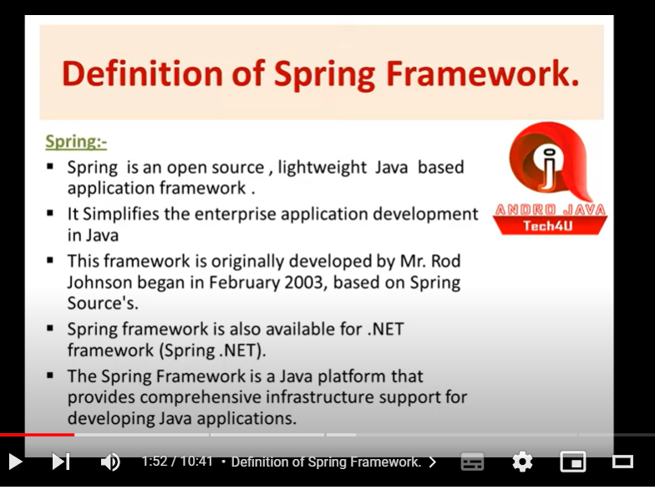

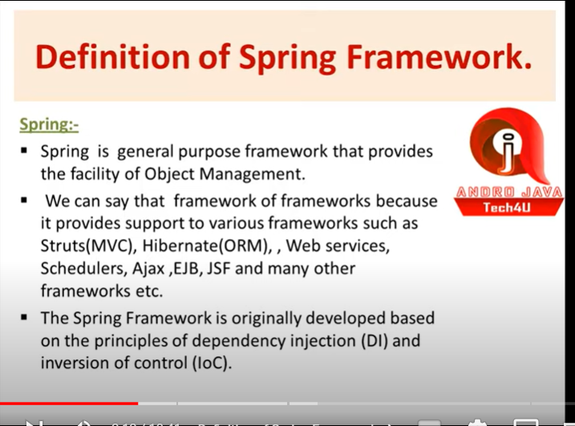

**Dependency injection and inversion of control spring main core module hain ise implement krta hain**

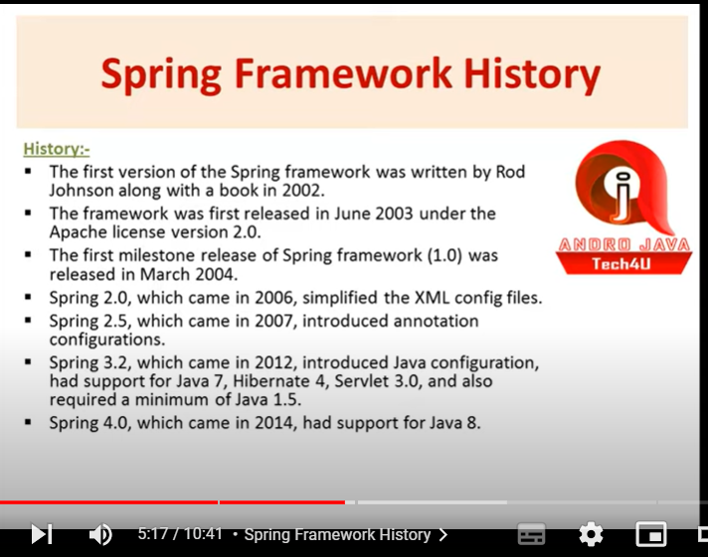

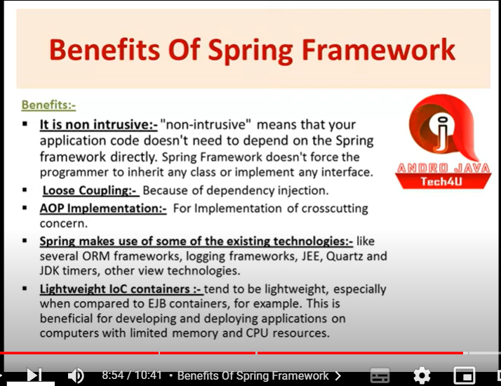

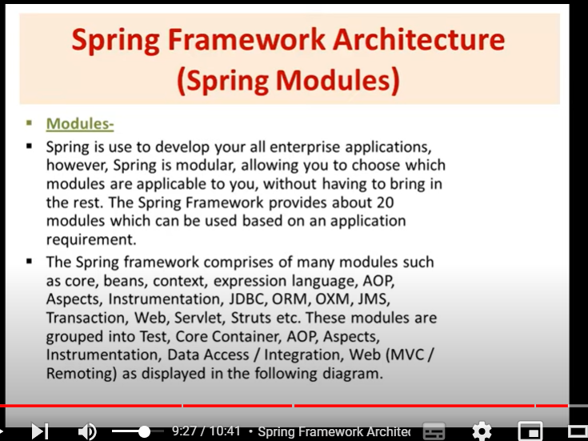

**Core madule:-spring khud banata hain runtime per iske andar IOC-container hota hain jo object banana ke liye responsible hota hain**

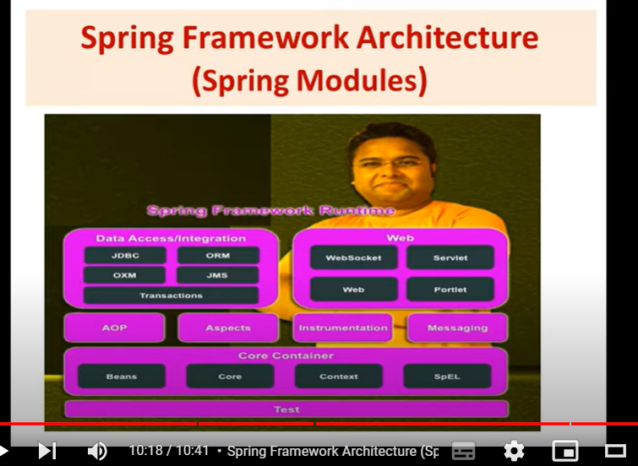

**Resouces folder main xml file ko kyu rakhate hain kyuki xml file ko resource bola jata hain isliye rakhate hain**

**DI(Dependency Injection):-**ek design pattern hota hain aur di se hum IOC achive kr sakate hian ,dono ek dusre ke implemention hain

**IOC(Inversion of cotrol**):-ye bhi ek design pattern hota hain is se hum DI achive kr sakate hain

* Ioc se di achive hota hain aur di se ioc ahive hota hain
* Ioc khata hain ye java program aaj se aapko object banana ki jaroorta nahi hain jo bhi ioc ko implement krega wo object banayega
* Isliye spring ioc ko implement krta hain aur spring ka core madule ioc per kaam krta hain
* Ioc per kaam krne ke liye spring walo api banayi
* 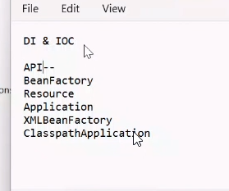
* Aur spring walo ne ek container banaya hain jo -ioc container -aur jo run time environment hota hain spring ke core madule ke liye
* Humari class ka object banana ka use handle krne ka ek environment provide krta hain
* Jab bhi humari class ka object banaya jata hain to use spring ki language main bean bolate hain
* Isliye bean ko handle krne ke liye jo ioc container ko handle krne ka liye iske andar api hain
* **IOC Container:- is the runtime environment for the spring .besically wo concept hota hain jo inversion of control per kaam krta hain -IOc main hume khud object nahi banana hota hain isme jo technology wo decide krti hain use kaise object banana hota hain**
* **Ye do part main categories hain**

1. **BeanFactory-parent interface of application context isme kaam feature hota compare with application context -**
2. **ApplicationContext**

The org.springframework.beans and org.springframework.context packages are the basis for Spring

Framework’s IoC container. The BeanFactory interface provides an advanced configuration

mechanism capable of managing any type of object. ApplicationContext is a sub-interface of

BeanFactory. It adds:

• Easier integration with Spring’s AOP features

• Message resource handling (for use in internationalization)

• Event publication

• Application-layer specific contexts such as the WebApplicationContext for use in web

applications.

In short, the BeanFactory provides the configuration framework and basic functionality, and the

ApplicationContext adds more enterprise-specific functionality. The ApplicationContext is a

complete superset of the BeanFactory and is used exclusively in this chapter in descriptions of

Spring’s IoC container. For more information on using the BeanFactory instead of the

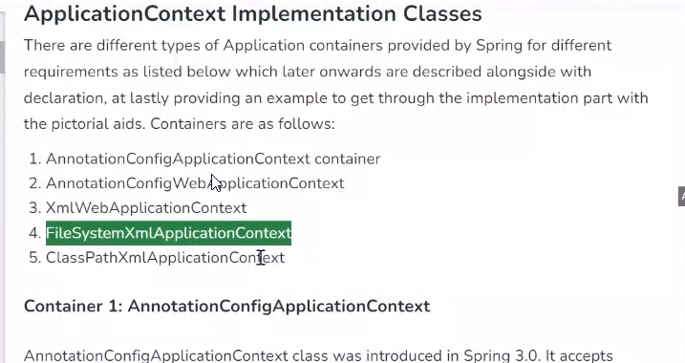

**Applicationcontext jo humari resource (file) hoti hain usko fatch krna hota hain sabse pahle**

**Iske liye bahut si class hoti hain**

**Ye jo applicationcontxt hoti hain use container load krega aur di krega aur object banayega**

**IOC-i**sme hum apni class ka object na banake technology responsible hoti hain humari class ka object banana ke liye

* Sping ke case main applicationcontext.xml file banati hain jis xml file main hum apni class ka naam de dete hain wo humari class ka object banata hain
* Actually wo humari class ka object aise banata hian wo runtime per humari class ko load krta hain newinstance se object banata hain aur uske id varriabale main pass kr deta hain

**DI**:-agar kisi varraible main koi value dalni hain to spring ek aur design pattern diya hain jise hum di kahate hain

* Di kahata hain agar class main koi varraible hain aur usme value dalani hain to ye meri dependency hain main usme value kaise dalu
* Di depency main do type ka depency injection hote hain

1. **Setter :-ke liye property tag hota hain**
2. **Constructor:aur iske liye constructor args tag hota hain**

**Note:-aur jab hum koi injection nahi krte hain to by default constructor injection hota hain**

* **Aur hune ek constructor banaya aur usme string value di aur to hume xml main type mention krne ki jaroorat nahi hain**
* **Agar humne ek se jada constructor banaye aur sab main ek value di kisi main string ,int ,float to usme jo type doge wahi chalegi aur type nahi do gi to string chalegi**
* **Aur constructor main sequence matter krti hain agar aapne ek constructor main 3 parametr dale int,string,float ya aap sequnec main likh de otherwise aap index ya type de de**
* **The main difference between the id and name attributes in Spring bean is that an id can only be assigned once to a bean, but a name can be assigned multiple times.The id attribute is used to uniquely identify a bean within a Spring container. It is a mandatory attribute and must be specified for every bean. The name attribute is an optional attribute that can be used to provide additional aliases for a bean.**
* **The only difference between an id and a name is that a name can contain multiple aliases separated by a comma, semicolon or whitespace, whereas an id must be a single value.17 May 2009**

# **Difference between constructor and setter injection**

There are many key differences between constructor injection and setter injection.

1. **Partial dependency**: can be injected using setter injection but it is not possible by constructor. Suppose there are 3 properties in a class, having 3 arg constructor and setters methods. In such case, if you want to pass information for only one property, it is possible by setter method only.
2. **Overriding**: Setter injection overrides the constructor injection. If we use both constructor and setter injection, IOC container will use the setter injection.
3. **Changes**: We can easily change the value by setter injection. It doesn't create a new bean instance always like constructor. So setter injection is flexible than constructor injection.

**Autowiring:-ek object ko dusre object automatic inject krata hain use autowiring kahate hain**

**@Bean:-**class method label annotation hota hain aur isme object hum khud se banate hain

**@Component :-**isme object hume spring khud banake deta hain aur ye class label annotation hota hain

**@ComponentScan:-**jo humne component se bean ka object banaya hain usko scan kr lega

**@Configuration:**javaconfiguration isliye banaya gaya hain kyuki yaha per sari bean honge kyuki jab hum configuration nahi lagate hain to xml main rakhte hain sare isliye hume lagana padta hain

**Life cycle of bean:**

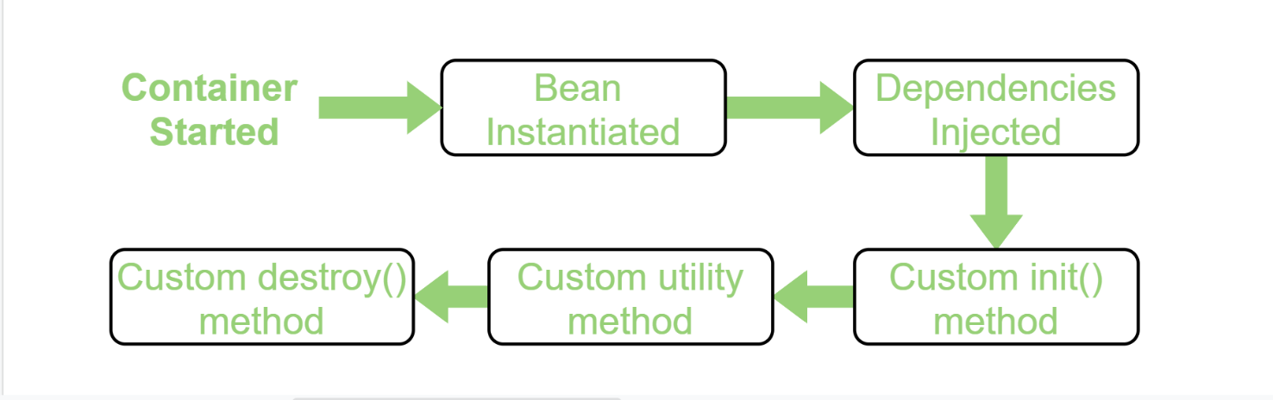

* Isme sabse pahle container started hota hain
* Aur uske baad bean instanited ka matlab hota hain bean ka object banata hain
* Aur uske baad jo class ki property hoti hain unke data ka inject krta hain
* Uske baad hum apna khud ka init method bana sakate hain aur uske baad
* Hum utility method bana sakate hain aur jab bean ka object destroy ho tab destroy method chale
* Destroy ke liye registerdatashutdownhook method ko call krna padta hain

**Spring Web:-**

* Ye MVC pattern per kaam krta hain
* Humare pass already jo design pattern the unme kuch kamiya thi isliye mvc design pattern picture main aya
* MVC(Modal Veiw Controller)
* Jab mvc nahi tha to us pahale 2 model hua krte the model-0,model-1
* Model-0,model-1 main kuch kamiya thi inhi kamiyo ki wajah se model 2 picture main jis hume mvc model kahate hain
* Kisi bhi web development ke liye 3 aaproach hote hain inhi is hum webapplication devlope krte hain (model-0,model-1,model-2)
* **Model-0**

**Isme hum pl,bl,dl sab ek hi jagah likhate hain jis se code humara ki redundancy badati hain aur code complex ho jata hain**

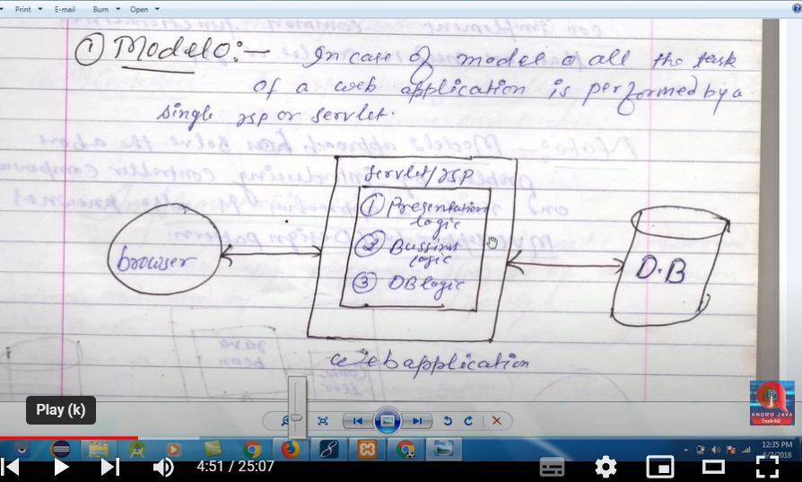

**Problem of Moduel-0**

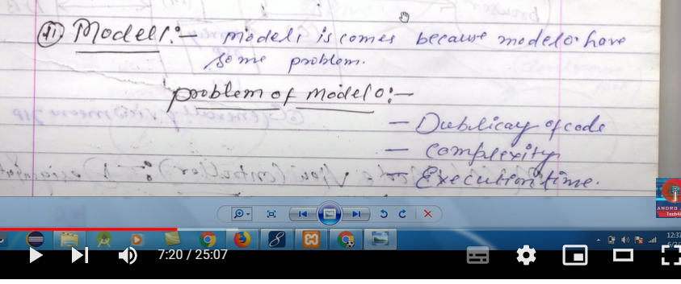

**Duplicasy code isliye agar hume authentication jsp ke liye krna hain to her jsp ke liye same code likhana padega**

**Model-1:-**model-0 main jo problem thie unhi problem ko door krne ke liye model -1 picture main aya

**Model -**1 main hum dto and dao class banate the but isme bhi kuch problem thi jise solve krne ke liye model-2 picture main aya

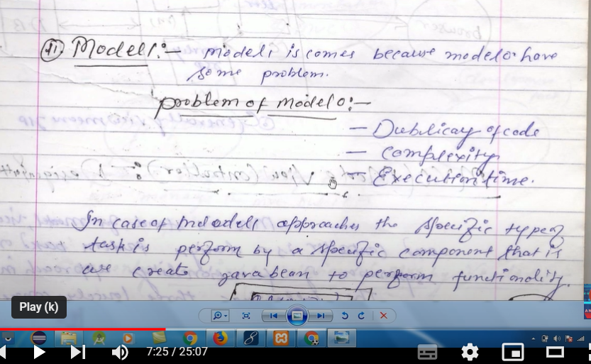

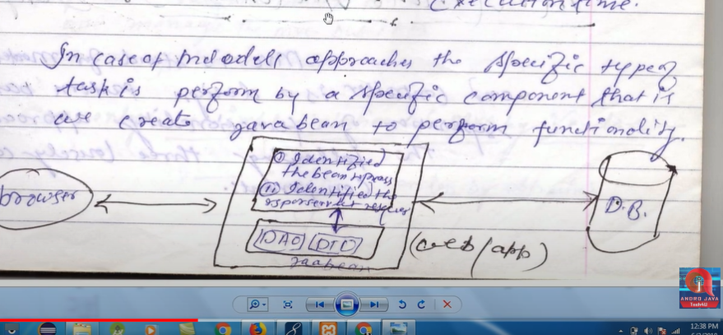

**Problem of Modol-1:-**isme problem ye thi isme her authentication ke liye alag-2 dao banana padta tha jaise for example -login ,register,mail is ye pata chala ki isme bhi kahi nak ahi duplicasy thi to ise ko door krne ke liye madule-2 picture main aya



* **Moduel-2:-**module main jo problem thi isi problem ko solve krne ke liye madule-2 picture main aya
* Hum kah sakate hain model-2 madule-1 ka enachement version hain
* Isme pl,bl,dl ko alag kr deta hain
* Design pattern ek guidline ek standered hote hain jo pahle se tested hote hain design pattern ki khas bate hain ye ki wo kabhi wrong output nahi dega
* Iska naam mvc isliye hain jab browse se request ati hain to usko control krne ke liye **central controle(filter)** hota hain aur jo request hain usko rakhane ke liye **madule** hota –
* **Module-**aapp kaha sakate hain ho madule us bolate hain jo client se aane wale data ko sambhal kr rakhata hain
* **View-**aur jo view hota hain wo servlet /jsp hota hain

**Note-**normal project main hum kya krte hain hum ek hi servlet/jsp main saare logic likh deta ho yap hir java bean bana lete ho

* **But mvc kahata hain jo common logic hain use aap ek seprate calss banake rakh lo -**central ke pass Rakha lo aur jis bhi jsp/servlet ko serve krana khud hi serve krayega
* 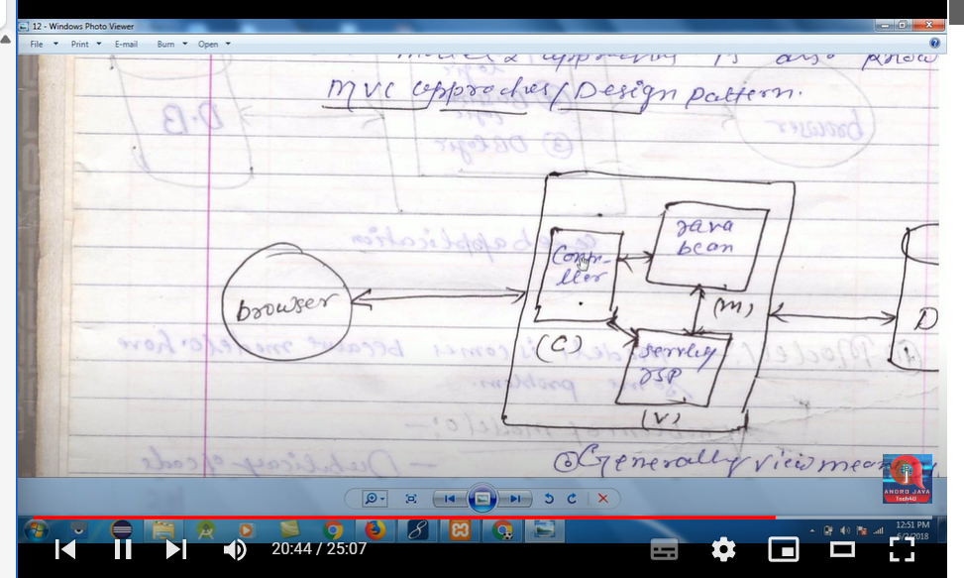
* 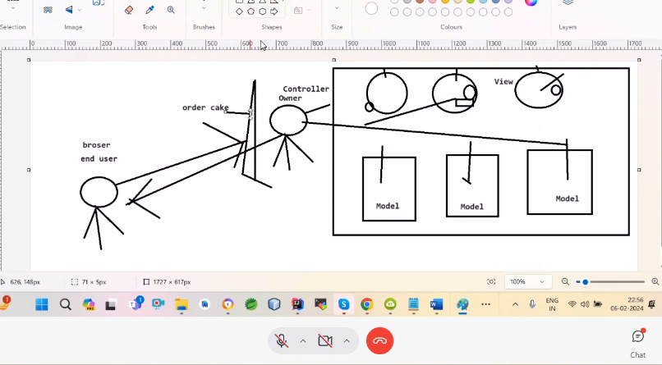
* Understanding the flow of spring Web MVC
* 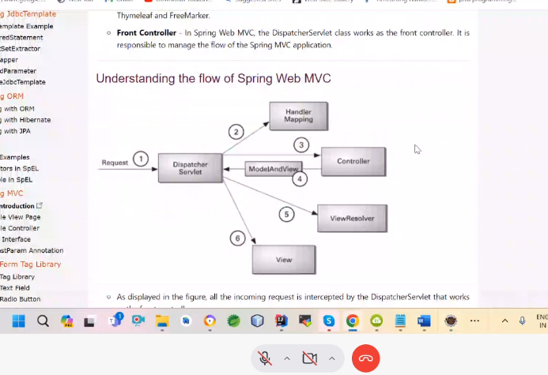

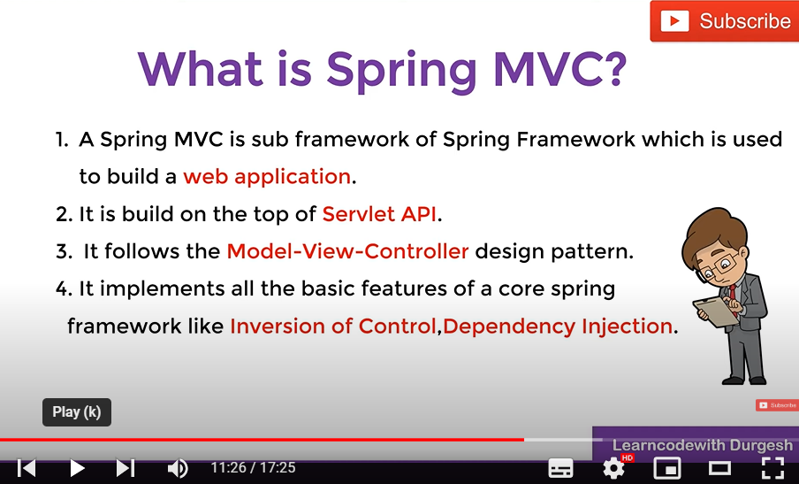

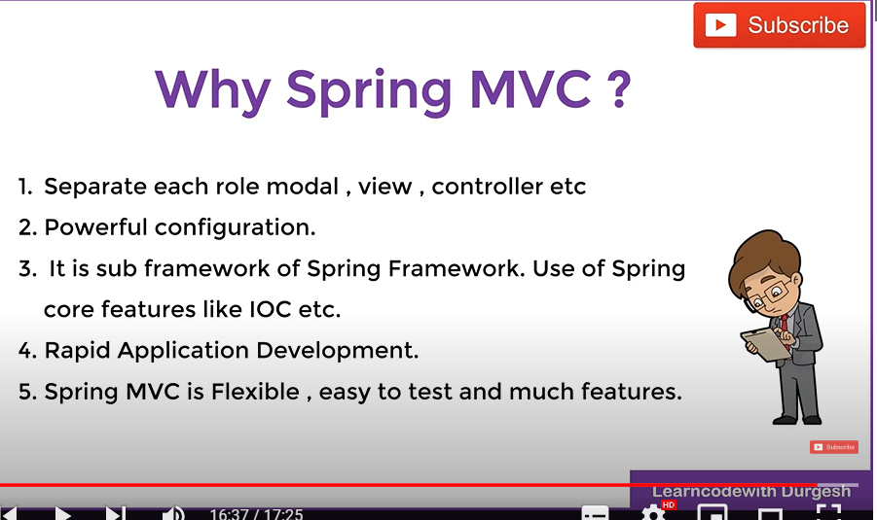

**Working of Spring MVC:-**

* Sabse pahle request client bhejega to waha dispatcher servlet( front controller) us request ko accept krega
* Aur front controller use request ko handlermapping class ki madad se us request ko transfer kr dega jo apna controller banaya hoga waha per transefer kr dega
* Ab controller us request ko handler krega dao,service layer ki madad se
* aur controller handler krene ke baad- data(model) and name of view wo delegate kr dega front controller ko
* aur ab front controller view resolver ki madad lega aur view ko resolve kr dega
* wo use location per dekhega prefix main wo location hoga aur suffix main wo view hoga
* aur uske baad response chala jayega front controller ke pass aur front controller us response ko client ko return kr dega aur client ko pata chalega muje ye page mila
* 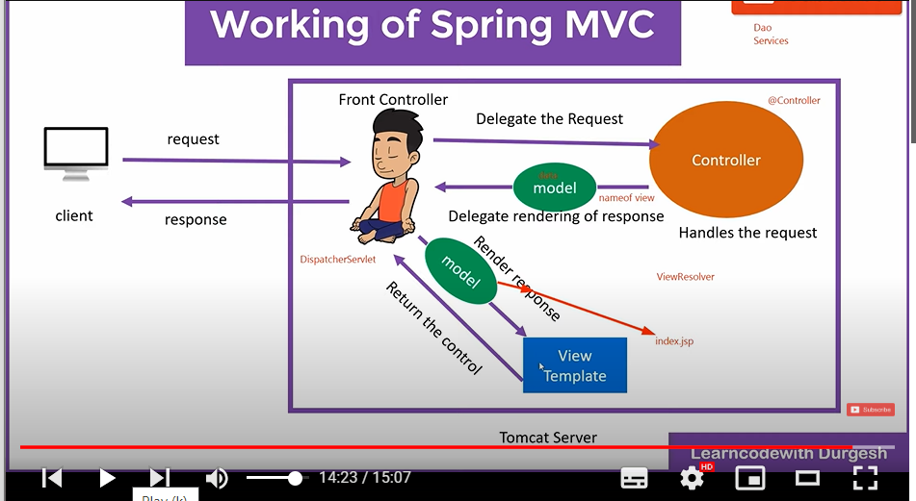
* Model-java class/bean
* Koi bhi controller class tab class kahalati hain jab aap abastracController class ko extends kro yaha per controller annotation lagao
* Jaise hi hum application ko deploye krenge to default page chalega agar hoga to
* Nahi hoga to aap
* @request mapping main / le lo to wo default ban jayega
* 404 client ko taraf kuch error hoga aap ko sahi krna hoga
* Dispatcher servlet bani banayi class hoti hain aur isme startup tag laga dete hain iske lagane se ye class deployment time per chalati hian aur hum isme url pattern jo lenge wahi cahlega
* Do get -server se data lena hain GetMapping and RequestMapping same hota hain
* 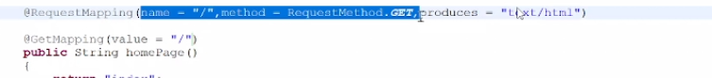
* Do post -server ko data dena hain
* **Service layer/dao**:-@service jo hota hain uske andar component laga hota hain ye ek standerd jab layer service to annotation service lagana chaiye code ki readiblity ke liye and service jaha per service milati hain
* **Service layer wo layer hoti hian jaha per main business logic likhate hain**
* **Repostirary/hibernateTemplate:**-hibernate template ka kaam krta hain iske andar bhi component laga hota hain code springboot ke term main ise repostery bolate hain isi ke andar sare method hote hain save,delete,update,retirive etc. and database se connection krne ke liye
* **Repostirory layer wo layer hoti hain jo seede data base interact krati hain jo database ki property ko sambhal ke rakhati hain**

**Dto :-**dto wo cheez rakho jo client ko dena hain ye ek standerd tarika hota hain

* Form se data dto main jana chaiye aur dto se data entity main jana chaiye
* Dto ka conversion ho jana chaiye entity
* Aur entity ko agar hum direct controller main kr denge to security constraints issue ho jayega
* Isliye hum ek class banani padegi jo dto ko entity main aur entity ko dto main convert kre
* view/jsp
* front controller- web.xml (dispatcher servelet)
* Controllers
* Model / Dto
* Entity Class (same as model but @entities)
* Dao / Service - same
* Repro (Hibernate Template)

**SpringBoot:**-

less configuration krke deta hain

* Jab hum singleton object main inject krenge prototype to waha singletion object dega uska behaviour change ho jayega
* But agar hum iskaa ulta krenge to nahi hoga
* Agar hume chahate hain behaviour change na ho to lookup annotation lagana padega

**SpringBoot MVC:-First project**

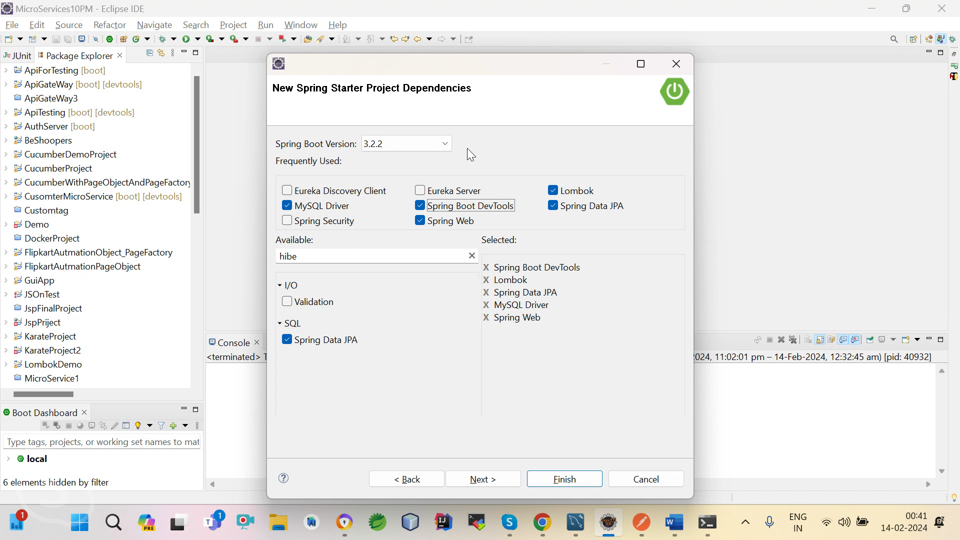

* Springboot main by default jsp ka support nahi hota hain wo thymleaf ko support krta hain wo jsp ko nahi chal payega
* Isliye hume jsper ki dependency dalani padegi jsp ke support ke liye
* Aur wo dependency same honi chaiye jo spring boot main tomcate ka version ho
* **JpaRepository interface springboot main use kiye jata hain iska kaam hibernate template ki tarah hota hain iske pass sare method hote hain insert ,delete ,update ,etc**
* **Aur uske jo enemuration wale main User,aur jo id liye ho ho wo dena padega**

**Devtool**:-project ko bina refresh kre jo bhi springboot project main change kroge apne app reload ho jayega ,norestart,noreload

**Service layer/dao**:-@service jo hota hain uske andar component laga hota hain ye ek standerd jab layer service to annotation service lagana chaiye code ki readiblity ke liye and service jaha per service milati hain

**Service layer wo layer hoti hian jaha per main business logic likhate hain**

**Repostirary/hibernateTemplate:**-hibernate template ka kaam krta hain iske andar bhi component laga hota hain code springboot ke term main ise repostery bolate hain isi ke andar sare method hote hain save,delete,update,retirive etc. and database se connection krne ke liye

**Repostirory layer wo layer hoti hain jo seede data base interact krati hain jo database ki property ko sambhal ke rakhati hain**

**Note:**front controller internally call hota hain aur basepackage same hona chaiye scan krne ke liye

**@ModelAttribute data ko get krta hain aur bean main jake set bhi krta hain**

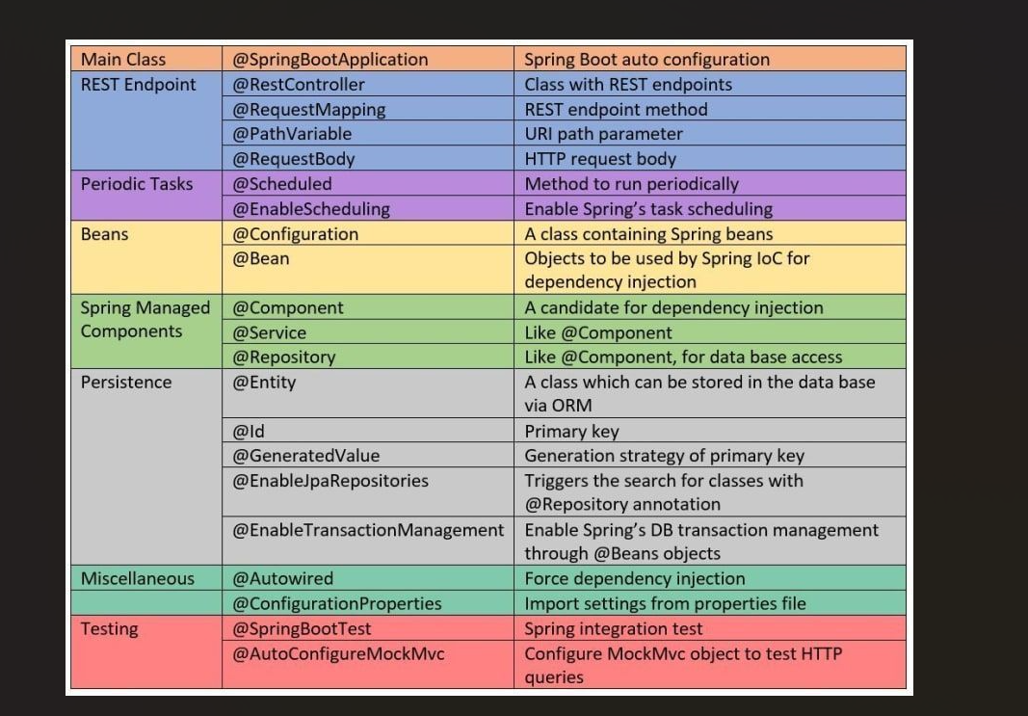

**Yml:-**intenation work krta hain isliye likhate hain,yahi use kiya jata hain aaj kl

Springboot main by default themyleaf ka hota hain view ke liye

**Dto :-**dto wo cheez rakho jo client ko dena hain ye ek standerd tarika hota hain

* Form se data dto main jana chaiye aur dto se data entity main jana chaiye
* Dto ka conversion ho jana chaiye entity
* Aur entity ko agar hum direct controller main kr denge to security constraints issue ho jayega
* Isliye hum ek class banani padegi jo dto ko entity main aur entity ko dto main convert kre

**Gradle kotilin ke saath use kiya jata hain**

**JPA :-**orm based framework hota hain wo kahata hain hume object do ,wo data ko save, update ,etc method hain wo kra dega aur yaha per sql query bhi nahi likhate hain

**Dto** :-database main data ko secure ke liye hum dto class banate hain

* For example pahle hume database main data dalane ke liye entity ka use krate the hum data ko get krke bean main set krte the
* But ab hum aise nahi krate hain aisa isliye nahi krate hain
* Hum separation of constrains pricnicple ko follow krate hain
* Separation principle kahate hain jo bhi kaam kro usko alag rakho
* Hum pahale data ko set bean hum karate the hum bean main na krke dto main krte hain
* Aisa isliye krte hain taki for example agar kal ko koi sql query main wrong input change kre to wo database main store ho jayega direct
* Jis se bachane ke liye hum dto ka use krte hain aur

2.Reason ye bhi hain agar hume partially data bhejna hain to hume dto class banani chaiye kyuki entity class main to sara data hota hain wo ja Sakata hain

**Mapper:-**

* Aur hum mapper class ka use krte hain dto and entity ka conversion krne ke liye
* Kyu jab hum database main data store krte hian to uske method hote hain wo dto ko nahi samaj sakate hain jaise save ,update etc ye dto ko nahi samaj Sakata hain
* To uske liye hum mapper class ka use krte hain jo dto ko entity main aur entity ko dto main conversion kr deti hain
* Yaha per aap struct bhi liberary bhi use krte hain

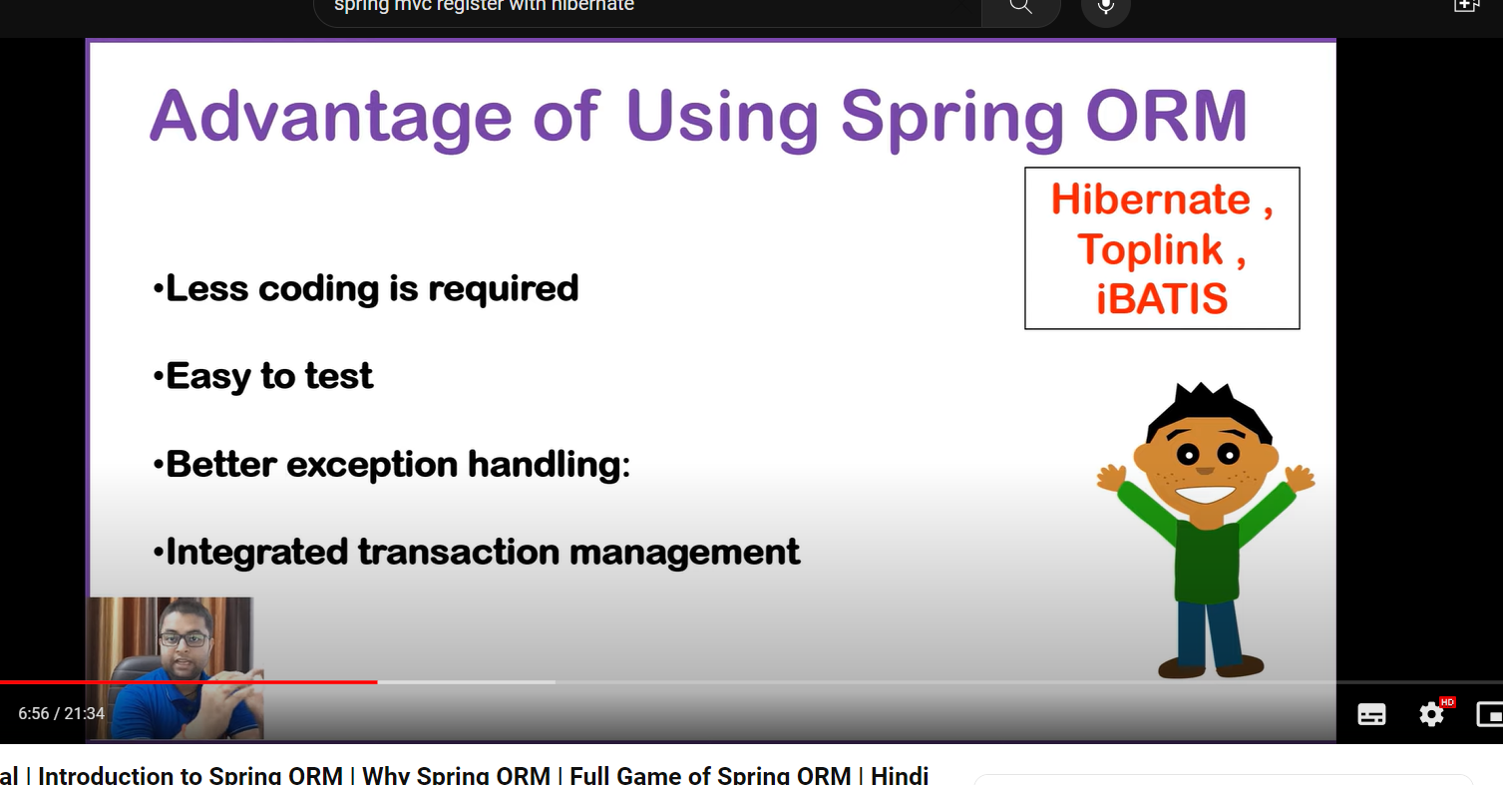

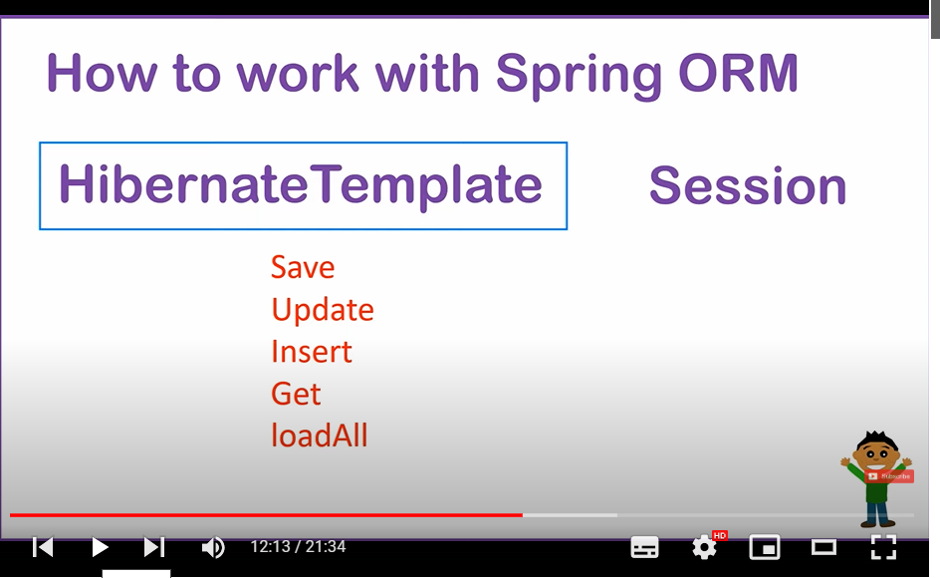

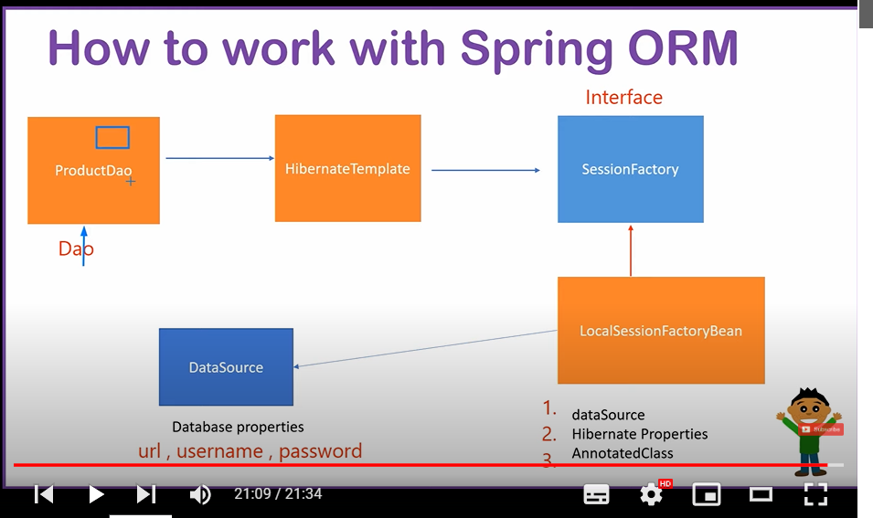

**Jab spring main orm tool use krte hain to spring** HibernateTemplte **name ko class hoti hain database se connection krne ke liye**

* **Agar aap chahate hain databse se connection krne ke liye spring main with hibernate to :**
* **Aap ek dao class bana le aur aapko hibernateTemplete ka object chaiye hoga**
* **To uske liye hum cfg class bana lenge aur mai hibernateTemplete class ka object IOC dwara dao ko denge**
* **But hibernateTempleate class sessionFactory interface per depend krati hian aur interface ka object banata nahi**
* **Isliye sessionFactory ki implement class ka object LocalSessionFactoryBean ka object hibernateTemplete ko dena hoga**
* **But Local SessionFactoryBean class ko 3 cheeze cahiey hoti hain**

1. **dataSource- jisme use jis databse se connection krna hain uska url,username,password,driverclass**
2. **HibernateProperties jaise -showdata,dialect,**
3. **Annotedclass**

<bean class=*"org.springframework.orm.hibernate5.HibernateTransactionManager"* id=*"transactionManager"*> <property name=*"sessionFactory"* ref=*"factory"*/> </bean>

**Data ko write krne ke liye hume bean class humhibernateTransectionManger class ko declare krna padega**

**Aur transactional annotation ke enable krne ke liye cfg file main annotation lagana padega jise hume** <tx:annotation-driven/>

**Java Mail Api:-**

**Rest Api:-**

hum isme presentation logic nahi likhate hain only business logic likhate hain aur jo hume kewal backend main krate hain use webapi bolate hain or webservices bolate hain

* **Api ko test krne ke liye hum postman software use krte hain**
* **Aur jo hum business logic likhanege to usko koi bhi technology user kr sakte hian for example dot.net ,php etc**
* **But koi bhi technology kaise user krenge to uske liye hum json use krte hain**

**What is difference between controller and Restcontroller**

Restcontroller combination of two thing @controller and @Responsebody

So that restcontroller use kiya jata hain every where

Webservice ko banana ki stayling hoti hain

* Soapservice:-ye purani technology hain
* RestService:-ye nahi service hain

@Responsebody:ye json ke form main data le jayega but agar ye nahi lagaoge to ye to application ko browser per le jayega

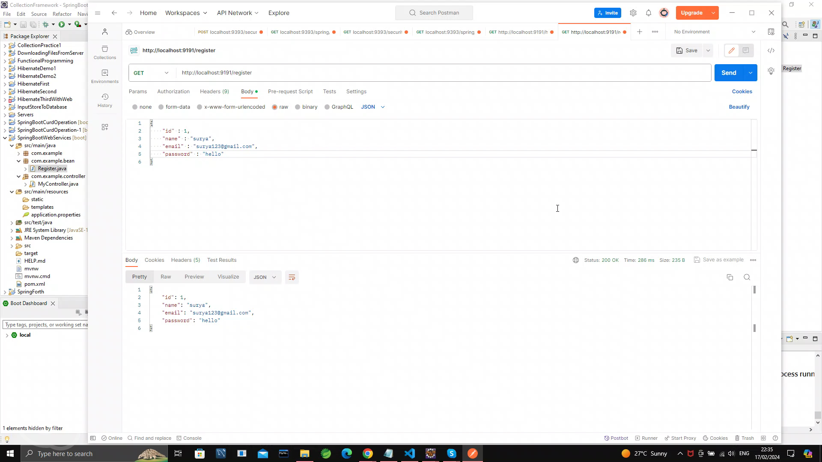

@Restcontroller is the combination of@ Responsebody and @controller

Base url jo controller class per deined krte hain to use base url kahate hain

**Validation:-**

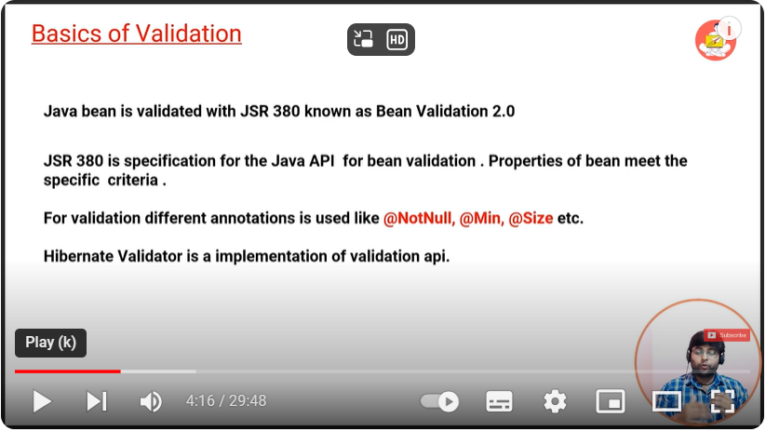

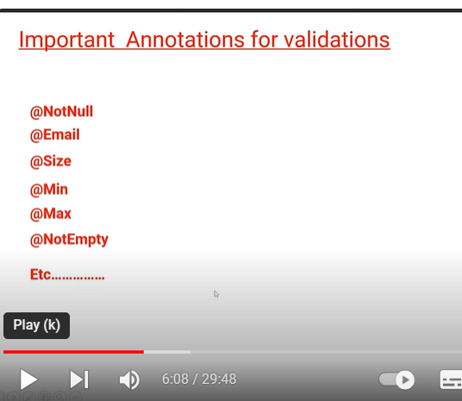

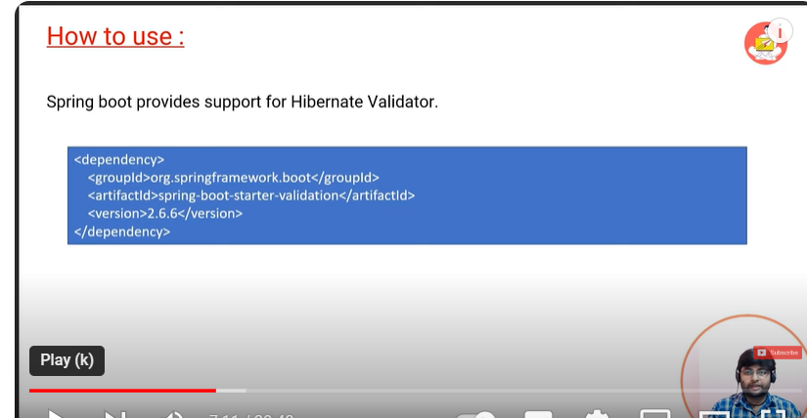

**Thing to keep in mind before creating spring boot rest apis:-**1)First we need to create a controller2)we need to create a dto class3)we need to create a entity4)we need to create Mapper class5)we need to create exception handler classs6)we need to create Mailsender where we will write our mailing program7)we need to create repository interface and extend with jpa repository interface8)we need to create a service interface and over there we have to define all the methods regarding to the apis9)we need to create the implementing class of the service interface where we will write our own business logic over there

**In Spring Boot JPA, calling a stored procedure involves using the @Procedure annotation along with the EntityManager. Here's a step-by-step guide on how to call a stored procedure using Spring Boot JPA:Define your stored procedure in your database: Before you can call a stored procedure, you need to have it defined in your database. Ensure it's created with the required parameters and logic.Create an Entity for the Stored Procedure Result (if necessary): If your stored procedure returns a result set, you might want to map it to an entity. If it's a simple value or a scalar result, you can skip this step.**

**Call the Stored Procedure using Spring Data JPA:Inject EntityManager into your service or repository class.Use the @Procedure annotation to call the stored procedure.Here's an example:Assuming you have a stored procedure named get_user_by_id which takes an id parameter and returns a User:**

**import org.springframework.data.jpa.repository.query.Procedure;import org.springframework.data.repository.CrudRepository;import org.springframework.data.repository.query.Param;import org.springframework.stereotype.Repository;@Repositorypublic interface UserRepository extends CrudRepository<User, Long> { @Procedure(name = "get_user_by_id") User getUserById(@Param("id") Long id);}In this example:UserRepository is a Spring Data JPA repository interface.The @Procedure annotation is used to indicate that the method should call a stored procedure named "get_user_by_id".The @Param annotation is used to specify the parameter name that will be passed to the stored procedure.Then, you can inject and use UserRepository in your service or controller to call the stored procedure:**

**import org.springframework.beans.factory.annotation.Autowired;import org.springframework.stereotype.Service;@Servicepublic class UserService { private final UserRepository userRepository; @Autowired public UserService(UserRepository userRepository) { this.userRepository = userRepository; } public User getUserById(Long id) { return userRepository.getUserById(id); }}**

**Parent tag ko dalane per normal project ko springboot main convert kr sakate ho:-**

* 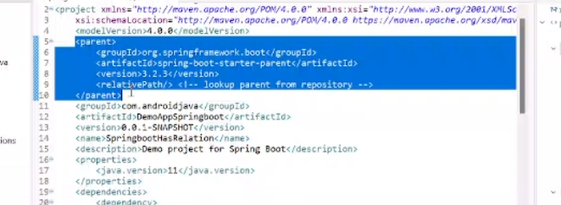
* Exclusion tag ko change krke hum tomcate sever exclude kr sakte hai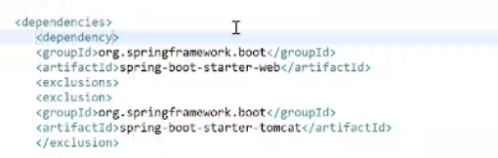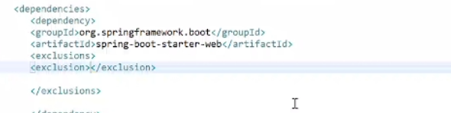

**Mapping:-**

**SpringSecurity:-**

**isko jaane se pahale do cheeze jaana chaiye**

**Spring security -**filter ko internally use krta hain aur different -2 type ki security hoti hain

* Springsecurity ke pass chain of list hoti hain -springsecurity ki
* Aur isme authenticationfiler by default chalta hain
* Spring security ko dalnae per jitane bhi url hote hain wo secure ho jate hain
* Jaise hi springsecurity ka features hum springboot main dalate hain, to springboot walo ne internally chain of list fileter ki internally bana rakhi hain ,jo hume console per dikhati hain
* Filter wo hota hain jo request ka preprocessing and response ka post processing krta hain
* Pahale jab hum springsecurity ka features nahi dale the to request distpatcher servlet ke pass jati thi but ab springsecurity ka features dalane per sabse pahale request filter ke pass jayegi
* Filter isliye banaya gaya hain hume project main security ki jaroorat hoti hain aur isme kai type ke filter hote hain aur security apko project main chaiye wo aap user kr sakate hain
* Aur isme ek fileter hota hain jo by default hota hain jise authorizationFilter(authencation) bolate hain

**1.Authenication**:-jaise aap kisi website ko open krna chahate hain to waha per username and password mangata hain to uski authentication boalta hain

**2.Authorization:-**jab aapne username and password dalake login kr liya but waha per jo access permission hoti hain jaise -aap ye open kr sakate hain aur bahut si cheeze open nahi kr sakate hain

**For example -**apne movie ki ticket li to wo ho gaya authentication but baithane ki permission kaha per baith sakate ho usi ko authorization bolate hain

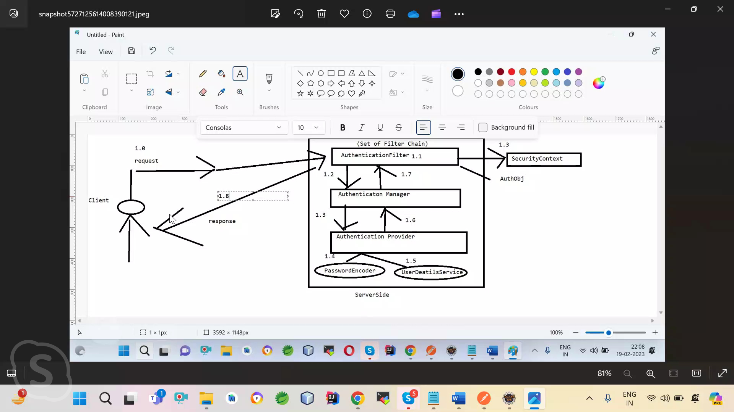

Authentication filter se request Authentication Manger ke pass jati hain

**Working of springsecurity:-**

* Jab hum springsecurity ka features dalate hain to sabase pahale filter chalta hain
* Aur uske baad dispatcher sevlet chalta hain aur same mvc hota hain baki ka

Basic Autnthitcation :-isme hum jo form html main khoalte hain agar hum ek class banaye SecurityConfig-to wo page java script main khulega

**SpringSecurity:-**

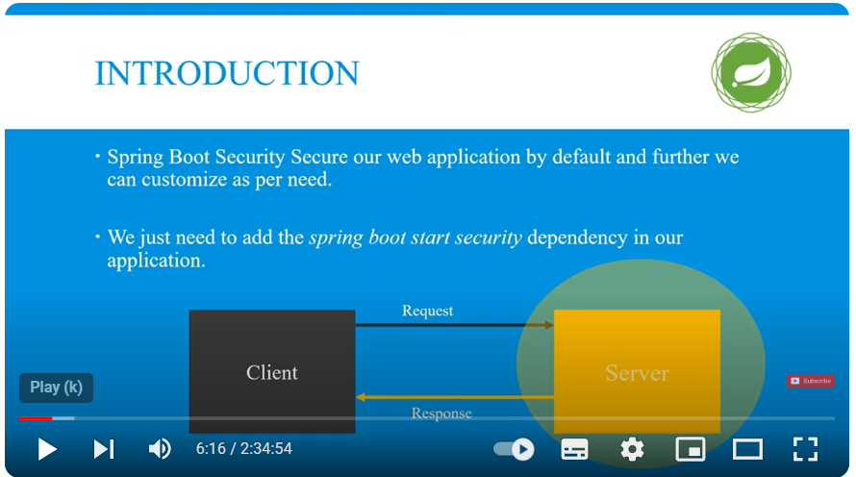

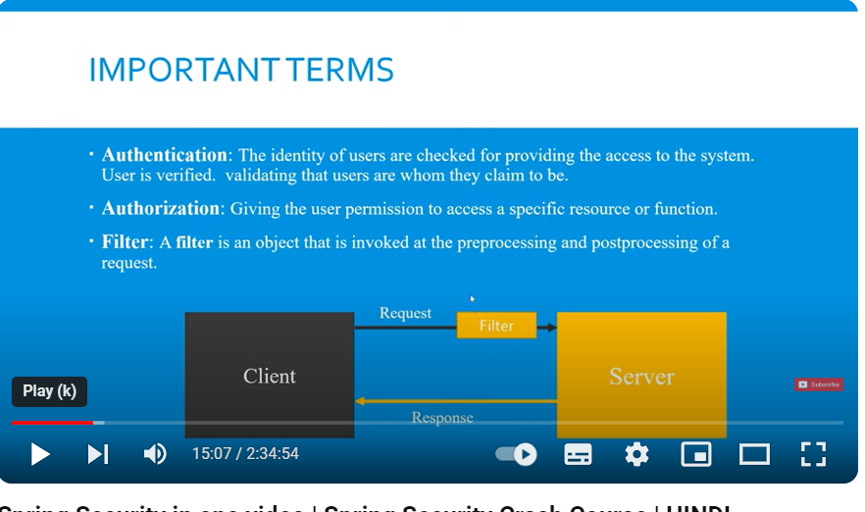

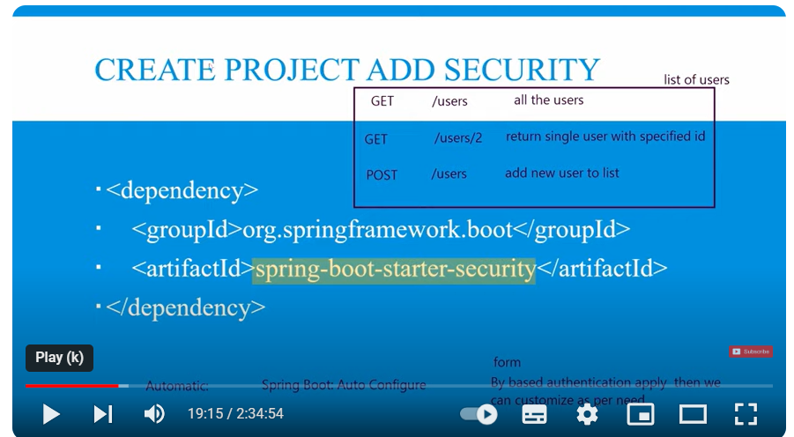

**How to works spring security:-**

* Sabse pahle filter request ko intercept krega aur authentication ka object banayega,basic information ko rakh dega aur delegate kr dega Authentication manger ke pass
* Authentication manger ki responsibility hain ki jo authentication ka object mila uske pass jo information kis band ke liye valid hain or nahi hain
* Authentication manger ek authenticate naam ka function call krta hain aur authentication pass kr deta hain
* Authenticate ke abastract interface hain aur iske pass koi tarika nahi authenticate krne ka
* Authenticate krne ke liye alag-2 provider hote hain but authtenication manger ko ye nahi pata hain konsa provider hain jo authenticate krega
* Islliye ye Authenticate manger call provider manger ko aur provider manger pata lagata hain konsa provider authenticate kr raha hain
* Aur Authentication Provider help leta hain userDetailService ki jo humare database se data lata hain
* Authetncation provider authentication function ko call kr lega aur yah se authentication ho jayega
* Jab authentication ho jayega to usi authentication object ke andar ek true krke property hoti hain use set kr dega
* Aur valid authentication humare providere manger ko return kr dega
* Provider valid authentication humer filter ko valid authentication bhej daga
* Aur fileter security context main us object ko set kr dega
* Aur jab security context main object set ho jayega to authentication ho jayega
* Aur request forward ho jayegi

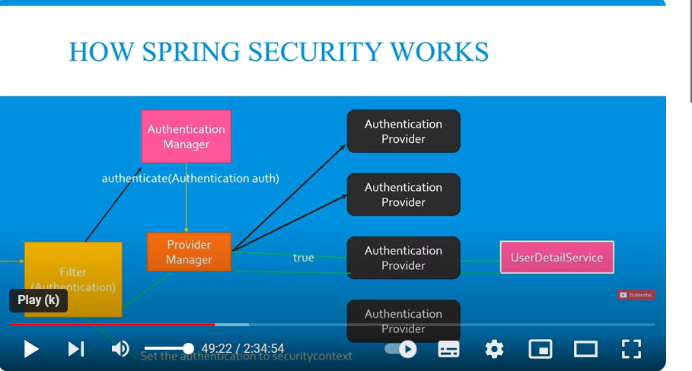

**Basic Authintcation:**

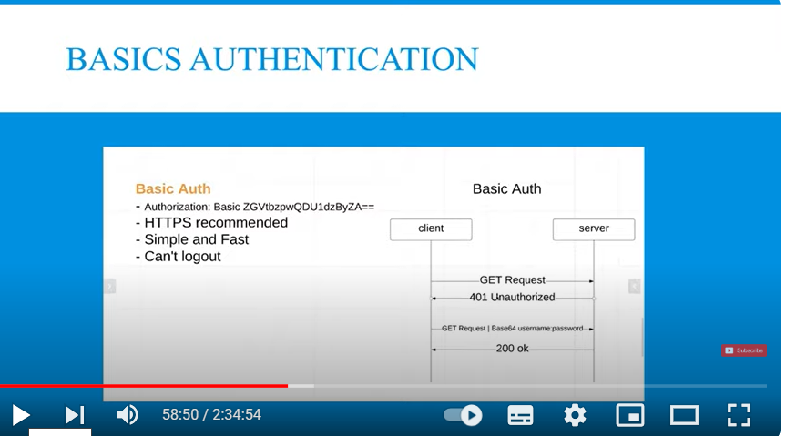

**Isme javascript man page khulata hain html wala hata jata hain**

**Notes:-**isme her bar username and password bhejna padata hain but agar apne likha hain requestMatchers.permitAll() to bhi username password dalana padega because kyuki app kiske liye allow kiya hain

But Jwt main aisa nahi hain aur HttpBasic(withdefaults) ye method jab call kroge to authentication hoga

**Important points**

* Basic Auth main permitAll krne per bhi password andusername dalana padega
* Isliye isme permitAll krna aur na krna same jab app permitAll nahi likhoge to bhi jo permitAll krna chaha rahe the uske liye username and password dalna padega
* has Any Role hain aap chahate hain jitane bhi role hain wo acess kre to app ko has AnyRole bhi likhana compulsory nahi
* but for example 3 role hain but app chahate hain do acess kre to appko likhana padega

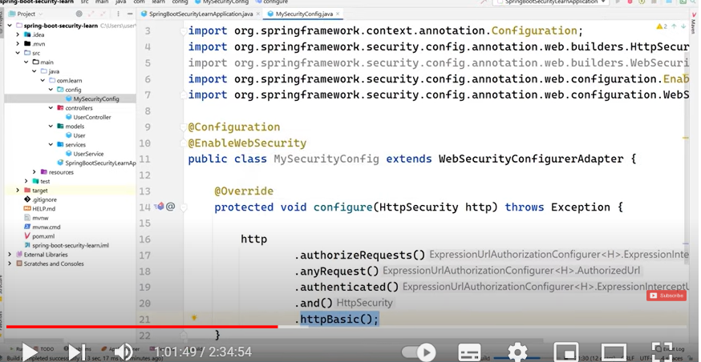

Ye tha <version>2.6.3</version>

**2.basic authentication main problem ye rahati hain agar sabake liye app ko username and password likhana hota hain**

@Bean

**public** SecurityFilterChain formLoginFilterChain(HttpSecurity http) **throws** Exception {

http.csrf(csrf -> csrf.disable())

.authorizeHttpRequests(authorize -> authorize

.anyRequest().authenticated()

)

.httpBasic(*withDefaults*());

**return** http.build();

}

**Ye wala springboot3 ka hain\*\*\*\*\*\***

**PasswordEncoder:-**jab hum database main password rakhate hain to ye recomnded nahi hota hain aap same rakh do kyuki same rakhane per hecak hone ke chance ho jate hain isliye hum password ko encode krte hain

**new** BCryptPasswordEncoder(10); ise se encode hota hain database main alag and fill alag krna hota hain

}

**Role:-high level overview Normal-Read**

**Authority**:-permission Read

**Admin:-**Read,Write,Update

**.csrf().disable() isko disable krna hota hain nahi to register nahi kr paoge correct password and user dalane per bhi ye secure krta hain isliye disable krna pdata hain**

Form Based Authethenitcation:-

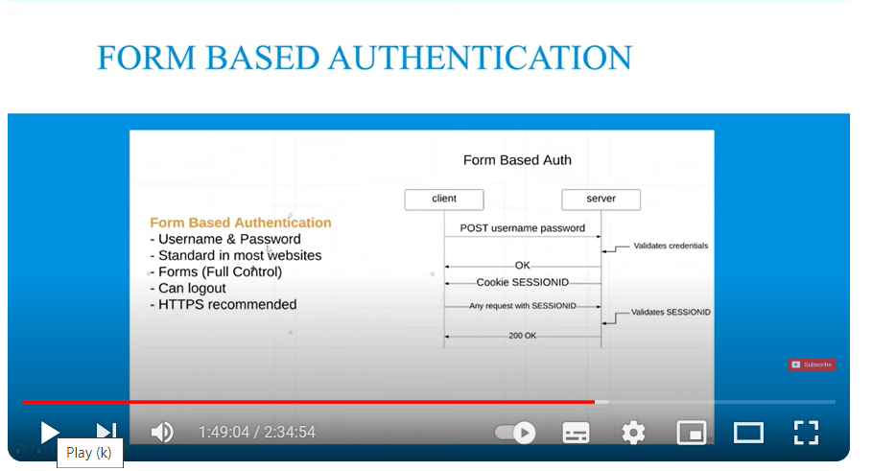

### **Conclusion**

In summary, when a user attempts to log in:

* The CustomUserDetailService fetches the user details from the database.
* If the user exists, CustomUserDetail wraps this user data and provides necessary information (like username, password, roles) to Spring Security.
* Spring Security then uses this information to authenticate the user and determine access rights.

This setup allows you to integrate custom user data sources and logic into Spring Security's authentication mechanism.

**How to work spring security-**

**With database:-**

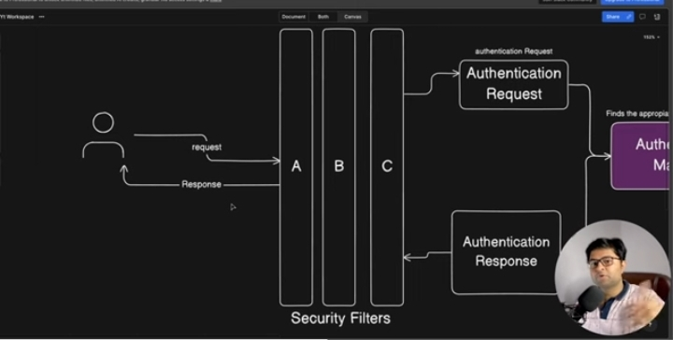

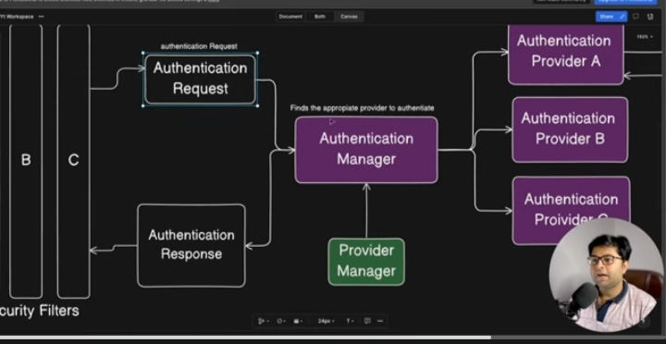

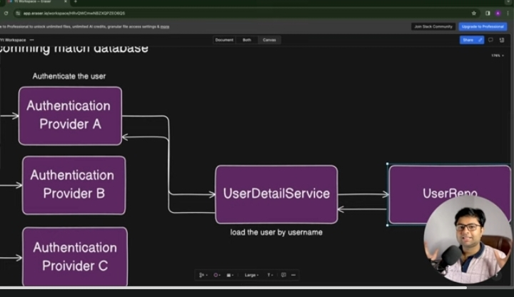

* Sabase pahle fileter request ko bhech main rok lega aur jo data hain uska object banake authentication ko de dega
* Authentication manger ek interface hain wo apni implement class ko object de dega aur wo implments class user detail service ko call lagayegi
* User service database main ja nahi sakata hain isliye userRepo database main jayega agar authentication manger ka object aur authentication manger ke pass object hain to username ko check krega userdetials service
* Aur same ho gayea to user ke pass us object ki sari detail bhej dega aur waha per checking hogi
* Username and password and role and authority springsecurity check krega
* Aur sath mai hi authentication manager main password encoder bhi pass krta hain ki apne jo password pass kiya tha wo Noop password pass kiya hian ya phir bcryptpassword pass kiya hain
* Aur sahi hu to waha se process ho jayega

Without database ye process internally ho jata hain

JWT:-Json web Token

**Jwt Token Important Points:-**

* Generate Token
* Header pass token
* Checking
* If show exception and not show exception get response

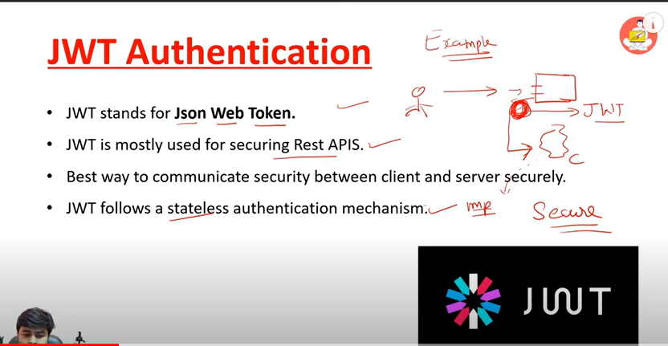

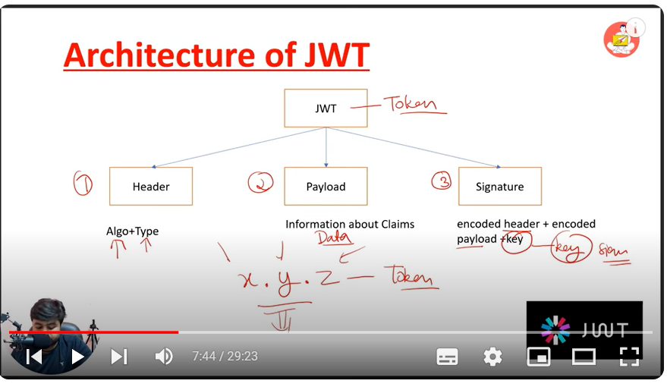

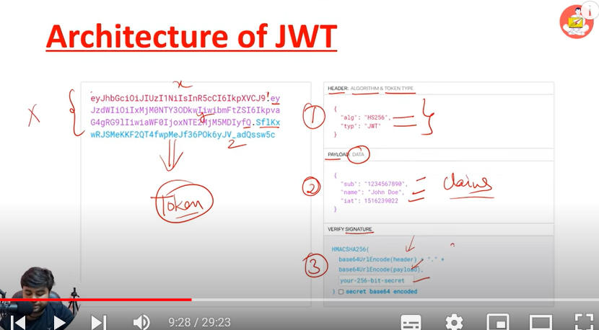

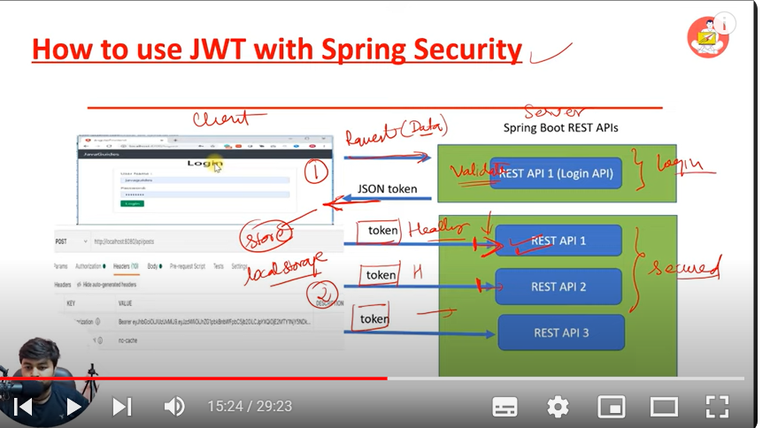

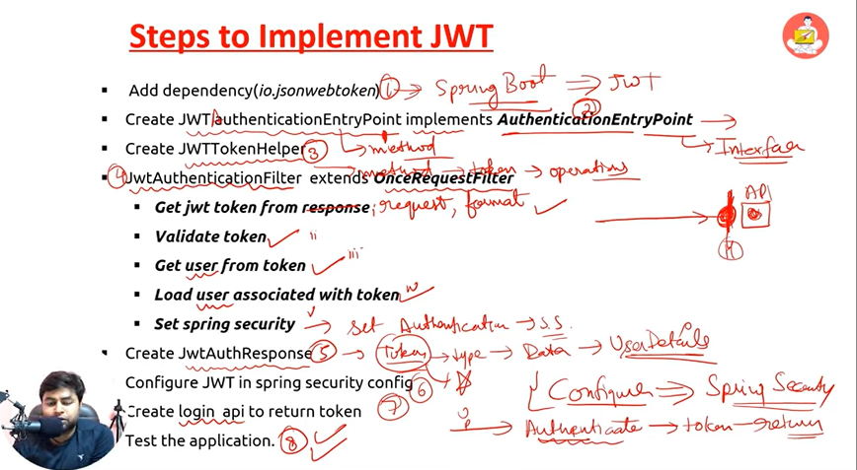

**Project for securing rest apis in few important step:-.**

1. Add dependency(io.jsonwebtoken)

2. Create JWT authenticationEntryPoint implements AuthenticationEntryPoint

3.Create JWTTokenHelper

4. JwtAuthenticationFilter  extends OnceRequestFilter Get jwt token from request Validate token Get user from token Load user associated with token Set spring security

5. Create JwtAuthResponse

6. Configure JWT in spring security config

7. Create login  api to return token

8. Test the application.

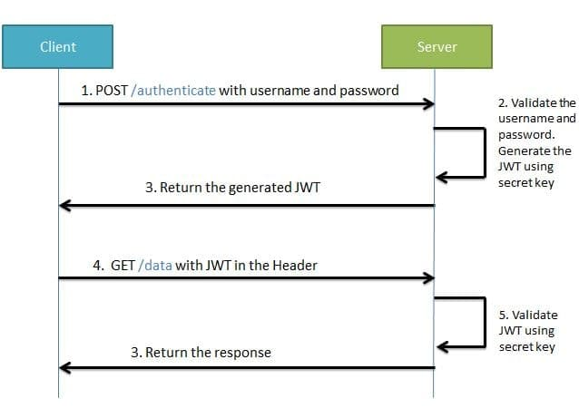

**Swagger:-**api ducment provide krta hainye ek tool hota hain

* Ye humne project banaya hain ye backend hain
* Aur agr hume iska fonted banabana hain to muje uko document generate krke dena padega aur wo
* Dekh ke samaj jayega

# Jwt Authentication with Spring Boot 3.1

# JWT Authentication with Spring Boot 3.0

* We will see how to configure InMemory user and jwt authentication using latest spring boot 3.0.
* We will create one protected endpoint and try to secure endpoint using spring boot security.

## Create new Spring Boot Project

* Go to spring initializer and create new project with dependencies
* add the following dependencies
* For Web

<dependency>

<groupId>org.springframework.boot</groupId>

<artifactId>spring-boot-starter-web</artifactId>

</dependency>

Copy

* For security

<dependency>

<groupId>org.springframework.boot</groupId>

<artifactId>spring-boot-starter-security</artifactId>

</dependency>

* Lombok

<dependency>

<groupId>org.projectlombok</groupId>

<artifactId>lombok</artifactId>

<optional>true</optional>

</dependency>

Copy

* For JWT

<!-- https://mvnrepository.com/artifact/io.jsonwebtoken/jjwt-api -->

<dependency>

<groupId>io.jsonwebtoken</groupId>

<artifactId>jjwt-api</artifactId>

<version>0.11.5</version>

</dependency>

<!-- https://mvnrepository.com/artifact/io.jsonwebtoken/jjwt-impl -->

<dependency>

<groupId>io.jsonwebtoken</groupId>

<artifactId>jjwt-impl</artifactId>

<version>0.11.5</version>

<scope>runtime</scope>

</dependency>

<dependency>

<groupId>io.jsonwebtoken</groupId>

<artifactId>jjwt-jackson</artifactId> <!-- or jjwt-gson if Gson is preferred -->

<version>0.11.5</version>

<scope>runtime</scope>

</dependency>

Copy

## Create End Point to be secured

@RestController

public class HomeController {

Logger logger = LoggerFactory.getLogger(HomeController.class);

@RequestMapping("/test")

public String test() {

this.logger.warn("This is working message");

return "Testing message";

}

}

Copy

**Use can create the same that we developed in video.**

## Create InMemory user with UserDetailService Bean

Create UserDetailService bean and write the InMemory user implementation

Create CustomConfig class and create bean and also create two important bean PasswordEncoder and AuthenticationManager so that we can use later.

@Configuration

class MyConfig {

@Bean

public UserDetailsService userDetailsService() {

UserDetails userDetails = User.builder().

username("DURGESH")

.password(passwordEncoder().encode("DURGESH")).roles("ADMIN").

build();

return new InMemoryUserDetailsManager(userDetails);

}

@Bean

public PasswordEncoder passwordEncoder() {

return new BCryptPasswordEncoder();

}

@Bean

public AuthenticationManager authenticationManager(AuthenticationConfiguration builder) throws Exception {

return builder.getAuthenticationManager();

}

}

**JWT Authentication Flow**

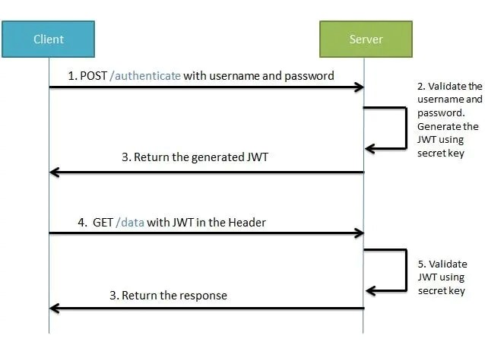

### Steps to implement jwt token:

**1)** Make sure spring-boot-starter-security is there in pom.xml

**2)**Create Class JWTAthenticationEntryPoint that implement AuthenticationEntryPoint. Method of this class is called whenever as exception is thrown due to unauthenticated user trying to access the resource that required authentication.

@Component

public class JwtAuthenticationEntryPoint implements AuthenticationEntryPoint {

@Override

public void commence(HttpServletRequest request, HttpServletResponse response, AuthenticationException authException) throws IOException, ServletException {

response.setStatus(HttpServletResponse.SC_UNAUTHORIZED);

PrintWriter writer = response.getWriter();

writer.println("Access Denied !! " + authException.getMessage());

}

}

Copy

**3)**  Create **JWTHelper**  class This class contains method related to perform operations with jwt token like generateToken, validateToken etc.

@Component

public class JwtHelper {

//requirement :

public static final long JWT_TOKEN_VALIDITY = 5 * 60 * 60;

// public static final long JWT_TOKEN_VALIDITY = 60;

private String secret = "afafasfafafasfasfasfafacasdasfasxASFACASDFACASDFASFASFDAFASFASDAADSCSDFADCVSGCFVADXCcadwavfsfarvf";

//retrieve username from jwt token

public String getUsernameFromToken(String token) {

return getClaimFromToken(token, Claims::getSubject);

}

//retrieve expiration date from jwt token

public Date getExpirationDateFromToken(String token) {

return getClaimFromToken(token, Claims::getExpiration);

}

public <T> T getClaimFromToken(String token, Function<Claims, T> claimsResolver) {

final Claims claims = getAllClaimsFromToken(token);

return claimsResolver.apply(claims);

}

//for retrieveing any information from token we will need the secret key

private Claims getAllClaimsFromToken(String token) {

return Jwts.parser().setSigningKey(secret).parseClaimsJws(token).getBody();

}

//check if the token has expired

private Boolean isTokenExpired(String token) {

final Date expiration = getExpirationDateFromToken(token);

return expiration.before(new Date());

}

//generate token for user

public String generateToken(UserDetails userDetails) {

Map<String, Object> claims = new HashMap<>();

return doGenerateToken(claims, userDetails.getUsername());

}

//while creating the token -

//1. Define claims of the token, like Issuer, Expiration, Subject, and the ID

//2. Sign the JWT using the HS512 algorithm and secret key.

//3. According to JWS Compact Serialization(https://tools.ietf.org/html/draft-ietf-jose-json-web-signature-41#section-3.1)

// compaction of the JWT to a URL-safe string

private String doGenerateToken(Map<String, Object> claims, String subject) {

return Jwts.builder().setClaims(claims).setSubject(subject).setIssuedAt(new Date(System.currentTimeMillis()))

.setExpiration(new Date(System.currentTimeMillis() + JWT_TOKEN_VALIDITY * 1000))

.signWith(SignatureAlgorithm.HS512, secret).compact();

}

//validate token

public Boolean validateToken(String token, UserDetails userDetails) {

final String username = getUsernameFromToken(token);

return (username.equals(userDetails.getUsername()) && !isTokenExpired(token));

}

}

Copy

**4)**Create JWTAuthenticationFilter that extends OncePerRequestFilter and override method and write the logic to check the token that is comming in header. We have to write 5 important logic

* 1. Get Token from request
  2. Validate Token
  3. GetUsername from token
  4. Load user associated with this token
  5. set authentication

@Component

public class JwtAuthenticationFilter extends OncePerRequestFilter {

private Logger logger = LoggerFactory.getLogger(OncePerRequestFilter.class);

@Autowired

private JwtHelper jwtHelper;

@Autowired

private UserDetailsService userDetailsService;

@Override

protected void doFilterInternal(HttpServletRequest request, HttpServletResponse response, FilterChain filterChain) throws ServletException, IOException {

// try {

// Thread.sleep(500);

// } catch (InterruptedException e) {

// throw new RuntimeException(e);

// }

//Authorization

String requestHeader = request.getHeader("Authorization");

//Bearer 2352345235sdfrsfgsdfsdf

logger.info(" Header : {}", requestHeader);

String username = null;

String token = null;

if (requestHeader != null && requestHeader.startsWith("Bearer")) {

//looking good

token = requestHeader.substring(7);

try {

username = this.jwtHelper.getUsernameFromToken(token);

} catch (IllegalArgumentException e) {

logger.info("Illegal Argument while fetching the username !!");

e.printStackTrace();

} catch (ExpiredJwtException e) {

logger.info("Given jwt token is expired !!");

e.printStackTrace();

} catch (MalformedJwtException e) {

logger.info("Some changed has done in token !! Invalid Token");

e.printStackTrace();

} catch (Exception e) {

e.printStackTrace();

}

} else {

logger.info("Invalid Header Value !! ");

}

//

if (username != null && SecurityContextHolder.getContext().getAuthentication() == null) {

//fetch user detail from username

UserDetails userDetails = this.userDetailsService.loadUserByUsername(username);

Boolean validateToken = this.jwtHelper.validateToken(token, userDetails);

if (validateToken) {

//set the authentication

UsernamePasswordAuthenticationToken authentication = new UsernamePasswordAuthenticationToken(userDetails, null, userDetails.getAuthorities());

authentication.setDetails(new WebAuthenticationDetailsSource().buildDetails(request));

SecurityContextHolder.getContext().setAuthentication(authentication);

} else {

logger.info("Validation fails !!");

}

}

filterChain.doFilter(request, response);

}

}

Copy

**5)** Configure spring security in configuration file:

@Configuration

public class SecurityConfig {

@Autowired

private JwtAuthenticationEntryPoint point;

@Autowired

private JwtAuthenticationFilter filter;

@Bean

public SecurityFilterChain securityFilterChain(HttpSecurity http) throws Exception {

http.csrf(csrf -> csrf.disable())

.authorizeRequests().

requestMatchers("/test").authenticated().requestMatchers("/auth/login").permitAll()

.anyRequest()

.authenticated()

.and().exceptionHandling(ex -> ex.authenticationEntryPoint(point))

.sessionManagement(session -> session.sessionCreationPolicy(SessionCreationPolicy.STATELESS));

http.addFilterBefore(filter, UsernamePasswordAuthenticationFilter.class);

return http.build();

}

}

Copy

**6)** Create JWTRequest and JWTResponse to receive request data and send Login success response.

**7)**  Create login api to accept username and password and return token if username and password is correct.

@RestController

@RequestMapping("/auth")

public class AuthController {

@Autowired

private UserDetailsService userDetailsService;

@Autowired

private AuthenticationManager manager;

@Autowired

private JwtHelper helper;

private Logger logger = LoggerFactory.getLogger(AuthController.class);

@PostMapping("/login")

public ResponseEntity<JwtResponse> login(@RequestBody JwtRequest request) {

this.doAuthenticate(request.getEmail(), request.getPassword());

UserDetails userDetails = userDetailsService.loadUserByUsername(request.getEmail());

String token = this.helper.generateToken(userDetails);

JwtResponse response = JwtResponse.builder()

.jwtToken(token)

.username(userDetails.getUsername()).build();

return new ResponseEntity<>(response, HttpStatus.OK);

}

private void doAuthenticate(String email, String password) {

UsernamePasswordAuthenticationToken authentication = new UsernamePasswordAuthenticationToken(email, password);

try {

manager.authenticate(authentication);

} catch (BadCredentialsException e) {

throw new BadCredentialsException(" Invalid Username or Password !!");

}

}

@ExceptionHandler(BadCredentialsException.class)

public String exceptionHandler() {

return "Credentials Invalid !!";

}

}

Copy

**8)**Test Application.

**AWS**:-ye deploye krne ke liye service provider krta hain BeanStalk,etc

**JavaMail Api:-**

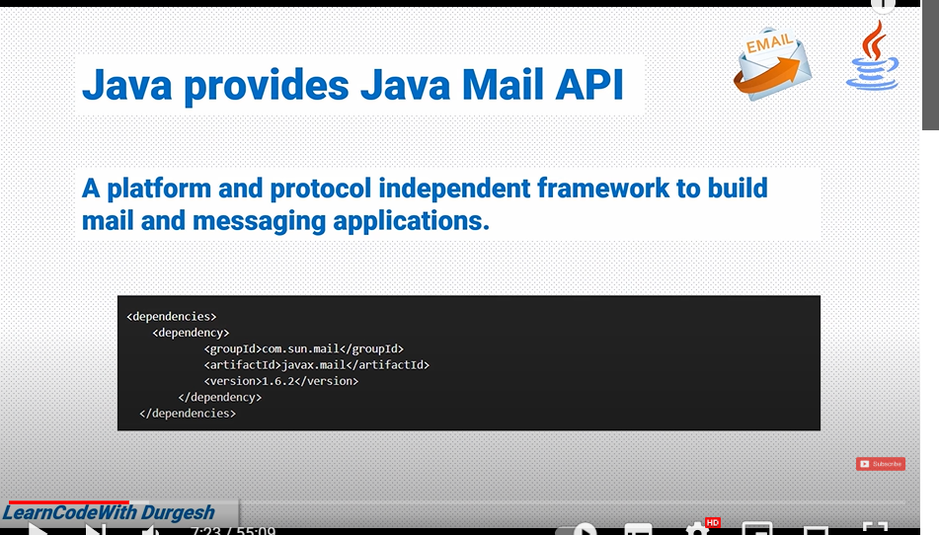

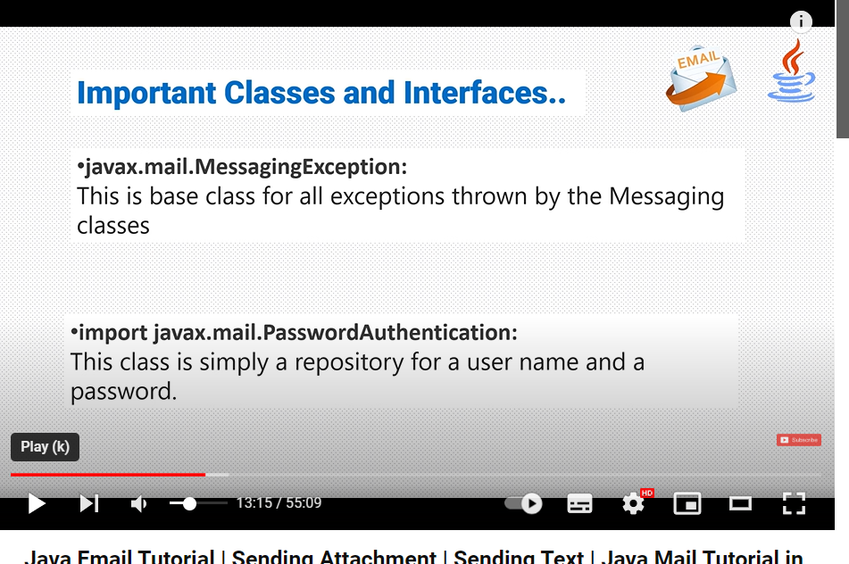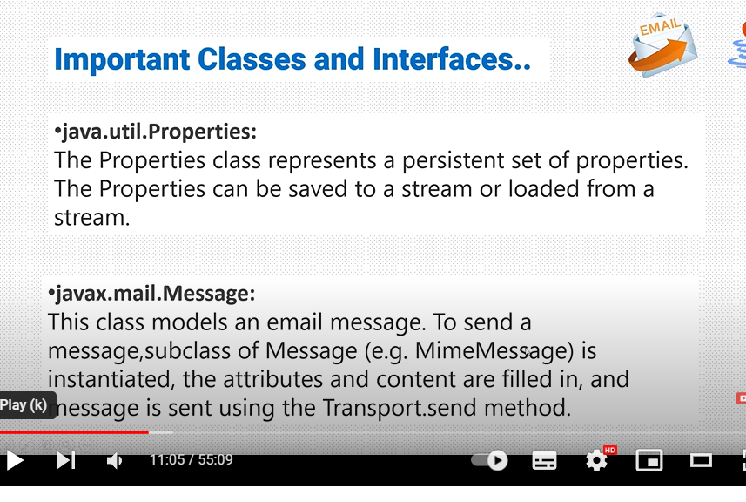

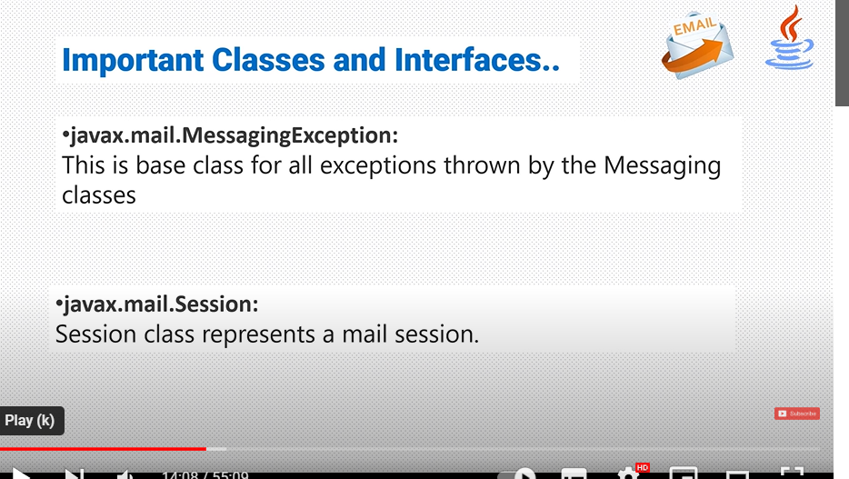

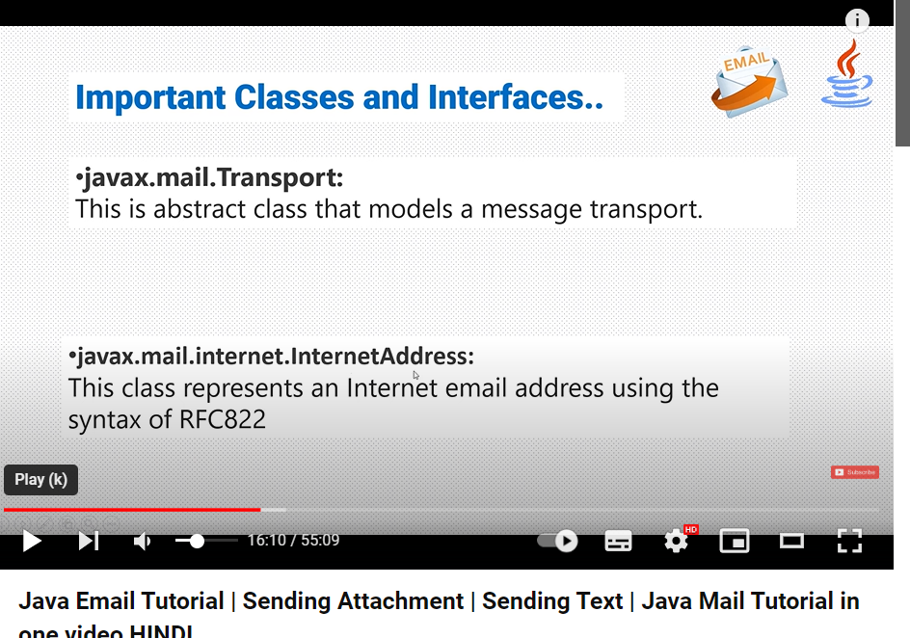

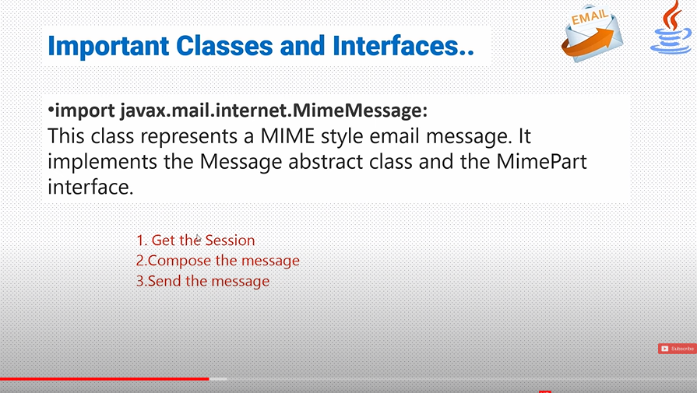

**Enviroment:-**jaise jaha per humne project banaya wo devlope environment,aur jaha deploye krege use hum kahate hain deployment environment

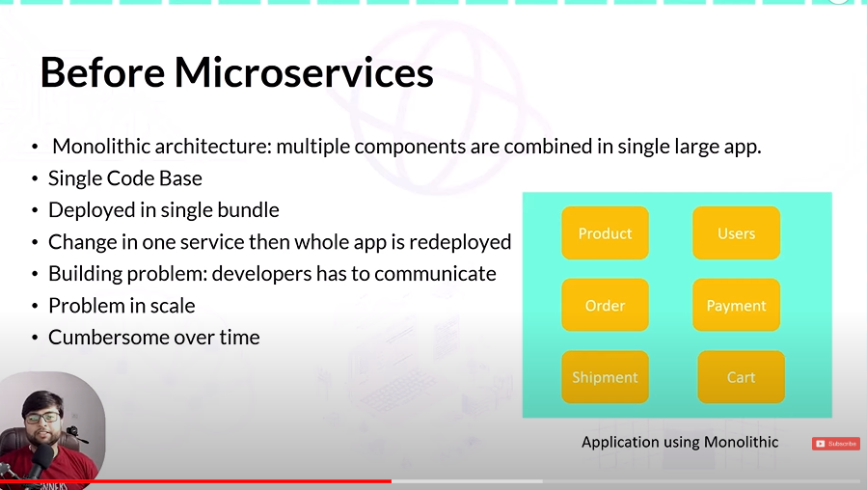

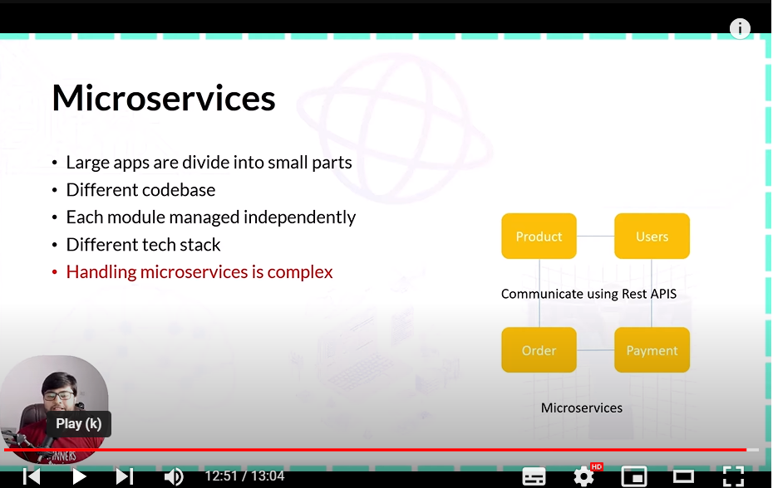

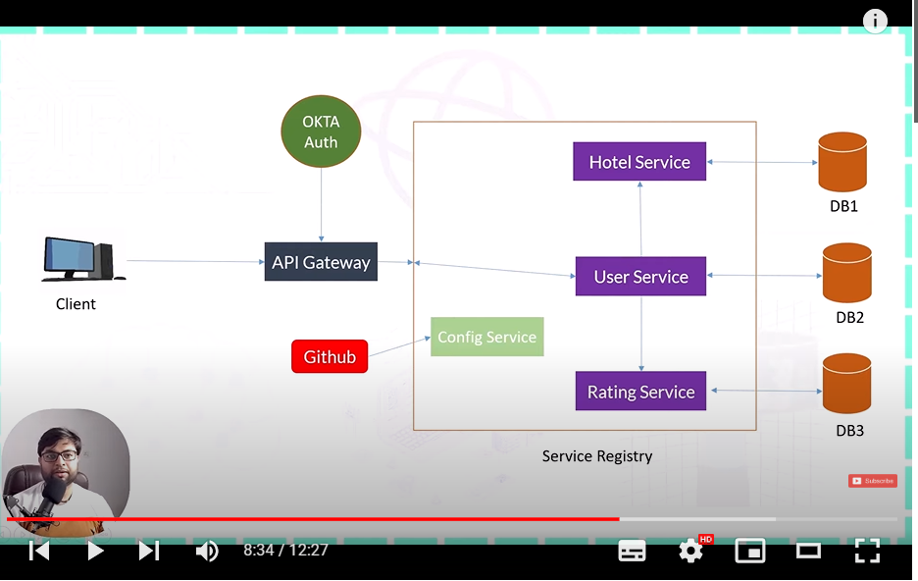

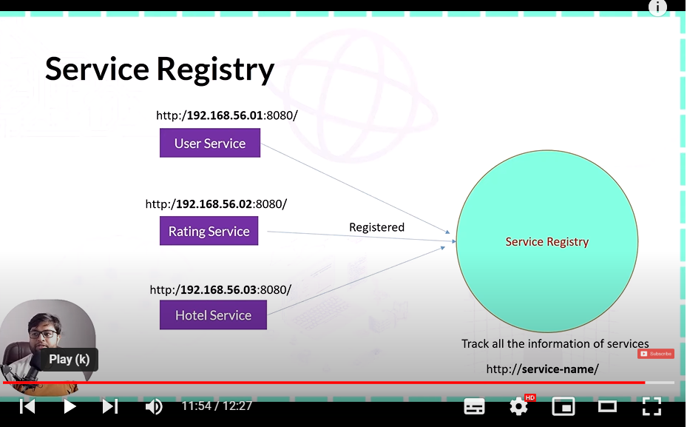

Ye service isliye banate taki saari service ko hum yaha per register kr paye

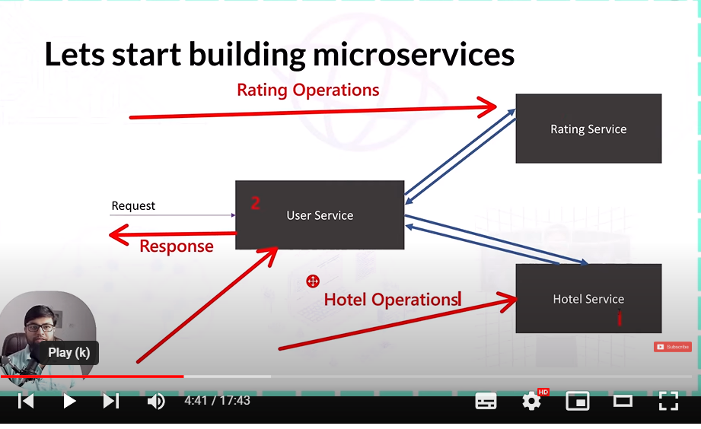

Microservices Communication:-

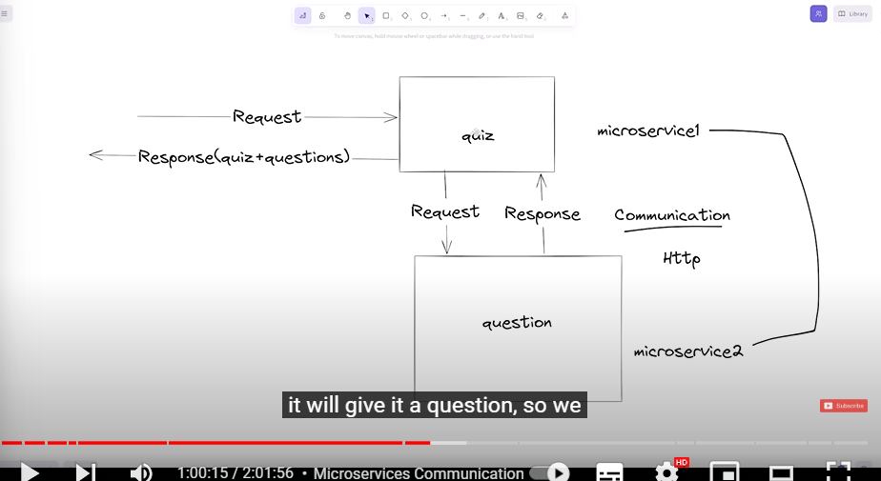

Foign clinet and RestTemplate dono se humse communicate kr sakate hain aur http se bhi kr sakate hain

**Config Server:-**

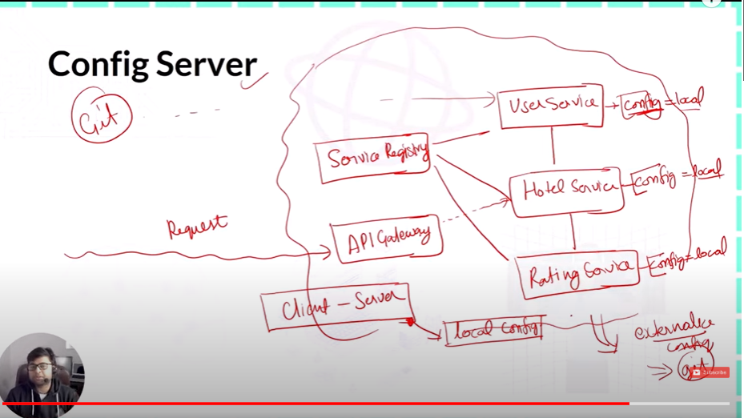

**Config server main hum configuration ko jo baar reapet ho rahi hain use external jagah per rakhat dete hain jise se hume cheezo ko repeat nahi krna hoga and for example and hard cord se dur ho jayenge hum log**

FoutlTolerance:-

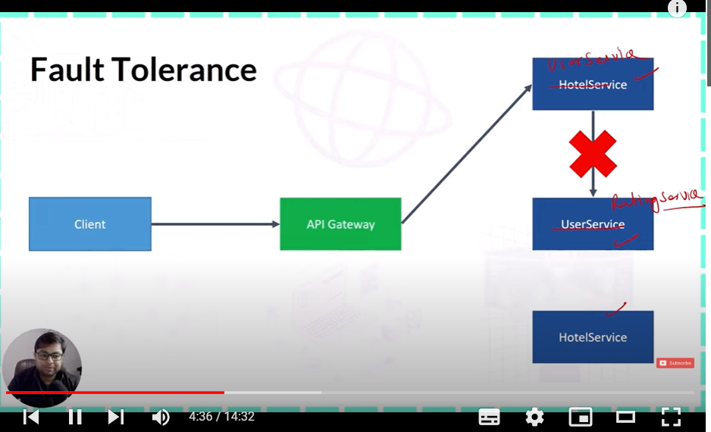

Jab ek service dusre ko communicate krati hain to kahi nak ahi wo dependen krne lagati hian dusre service per to waha per foult a sakate hian agar do service main ek service down to

To usi ko fult tolrence kahate hian

**Isko dure ktne ke liye circuit breaker use krate hain**

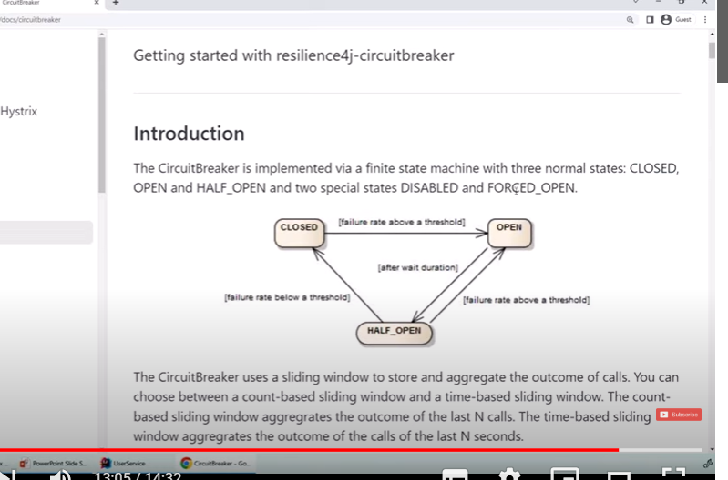

**Retry:-**jab aisa ho ki service down but muje nahi pata hain ki down but maine pahali baar try kiya to muje laga ki down hain but wo response nahi de payi to hum is use krte hain

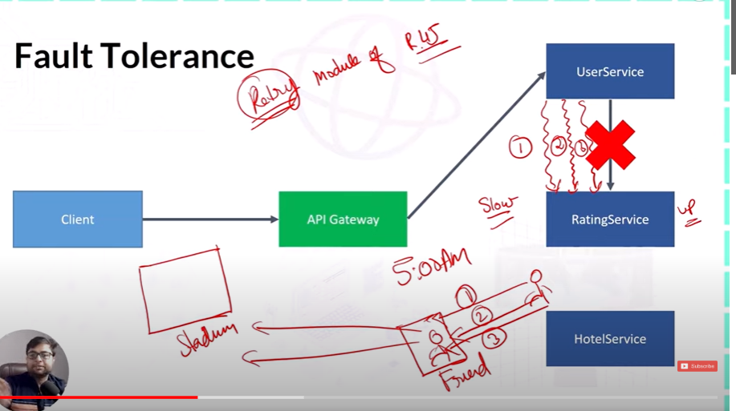

**1.** @CircuitBreaker(name = "ratingHotelBreaker", fallbackMethod = "ratingHotelFallback")

2. @Retry(name = "ratingHotelService", fallbackMethod = "ratingHotelFallback")

**Rate Limiter:-** **rate limiting security and perfomarnce ko badan ke liye lagata hain**

Security:-humari service per bahut saare attack kr diye jate hain lakh to us attack se bachane ke liye hum to hum use krte hain rl meter laga dete hain

Performance:-mana koi client hain usne ek minute main 100 request kr di but sevice 50 request hi kr par rahi hain response to waha per hum rl use krte hain uski perofomance badane ke liye

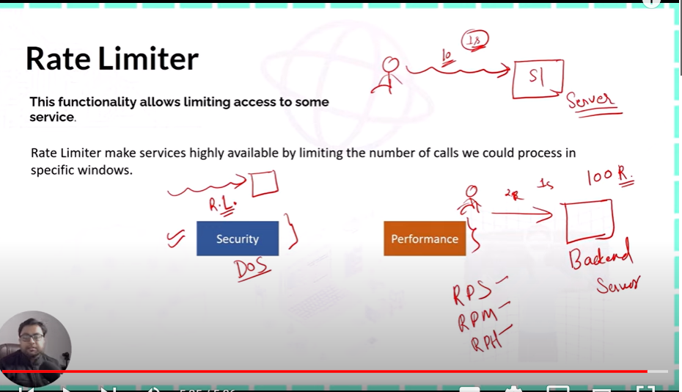

**Security with OKTA:-**

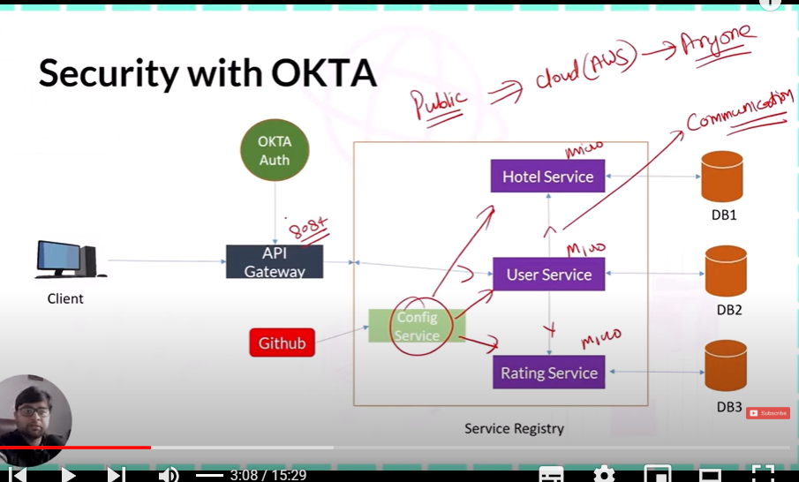

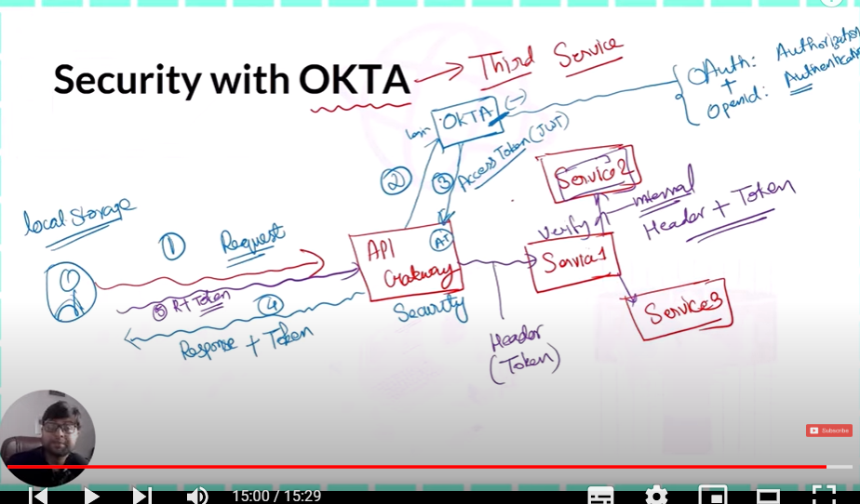

**@SpringBoot Application:-**

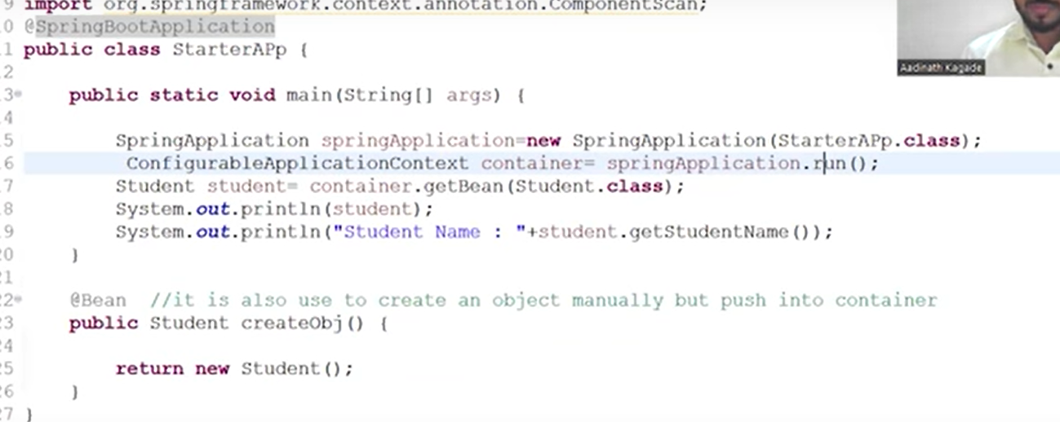

• @EnableAutoConfiguration: This annotation enables Spring Boot's auto-configuration mechanism, which attempts to automatically configure your Spring application based on the jar dependencies you have added.

Dispatcher servlet ko load krna use enable krne ka kaam krta hain

• @ComponentScan: This annotation tells Spring to scan the current package and its sub-packages for Spring components like @Controller, @Service, @Repository, and custom @Component classes.

Is class ke andar jitane bhi class hain unka kam ye krta hain

• @Configuration: This annotation indicates that the class can be used by the Spring IoC container as a source of bean definitions.

run method:-

The SpringApplication.run() method is used to launch a Spring Boot application. It bootstraps the application, starting the Spring context, auto-configuring the components, and eventually launching the embedded server (like Tomcat, Jetty, or Undertow) if a web application is being developed.

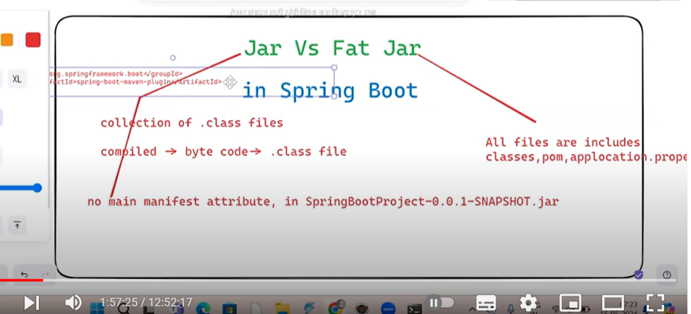

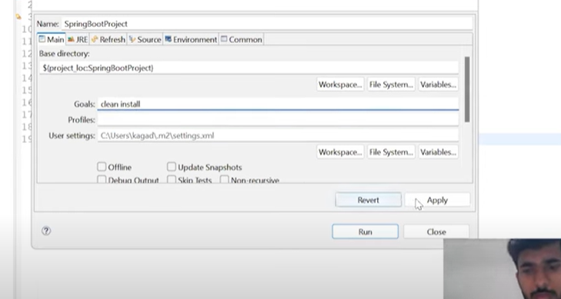

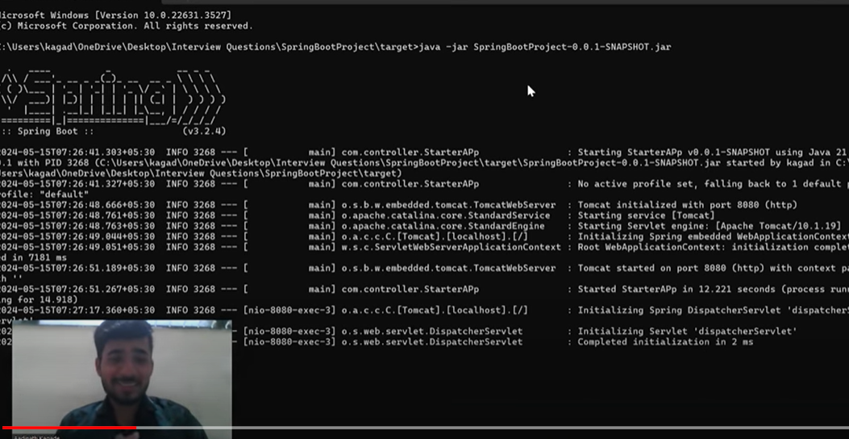

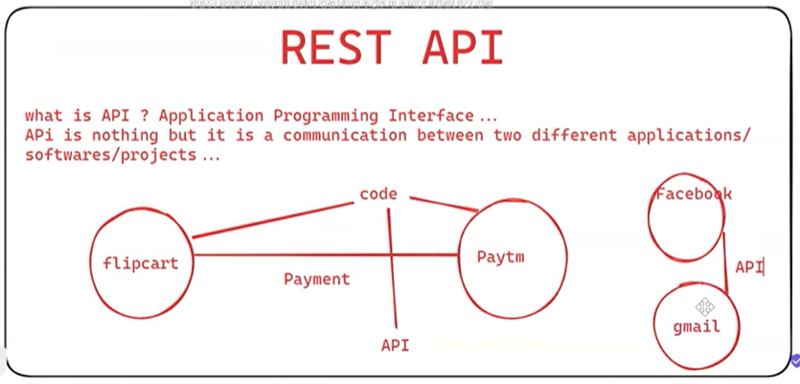

**MicroServices:-**

There are some steps use to create microservice-

**1-Service Registery-**

* In this registery if you service registry port number 8761 this default port eureka server
* API Gateway automatically and other service call there is no register eureka server in ApiGateway application.yml
* But if 8761 except use port number then any service entry compulsry service registry
* Config server transefer github data but it is not use itself
* For example service registry port use 8181 and in this time you will have to entry compulsory in configservice
* Service reistery this property write compulsory

**Client side-eureka.client.serviceUrl.defaultZone=${EUREKA_URI:http://localhost:8761/eureka}**

**Service Registery-**

**serviceUrl:**

**defaultZone: http://${eureka.instance.hostname}:${server.port}/eureka**

**MicroService Communication:-**

There are two type mc

**Rest Template:-** config class and load balncing –loadbalanced annotation

**FeignClient:**-add dependency open feign and create interface client and enable fielclients

Config Server-add dependency config server and discovery client because this register in service registery

Link github and other microservices link this configserver